**MAJOR PROJECT -4**

**Jenkins Master-Slave Configuration**

* Method-1: Create one master and five slave nodes and install nginx (Slave-1), httpd (Slave-2), SonarQube (Slave-3), tomcat (Slave-4) and deploy any one Static application in any one of the web servers (httpd & nginx) (Slave-5).
* **Slave 1: Installing NGINX through Jenkins Master Slave Configuration.**
* Launch an Instance for Master node.

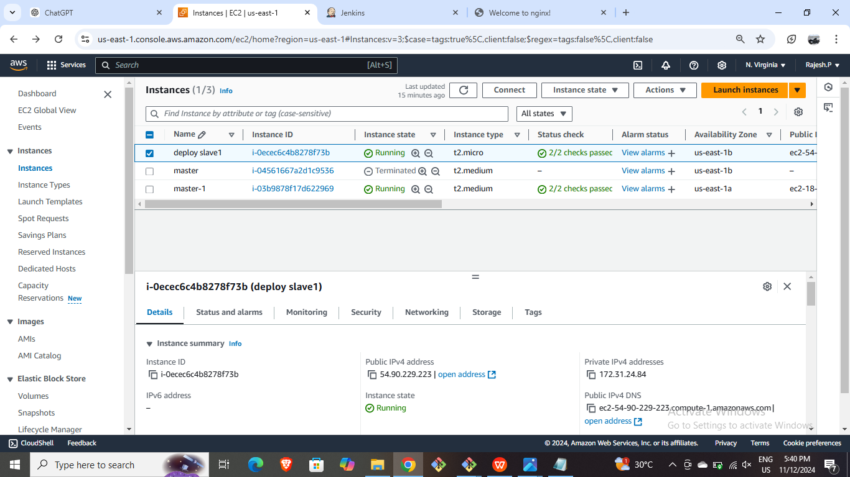

* Connect it through CLI and install Jenkins in it.

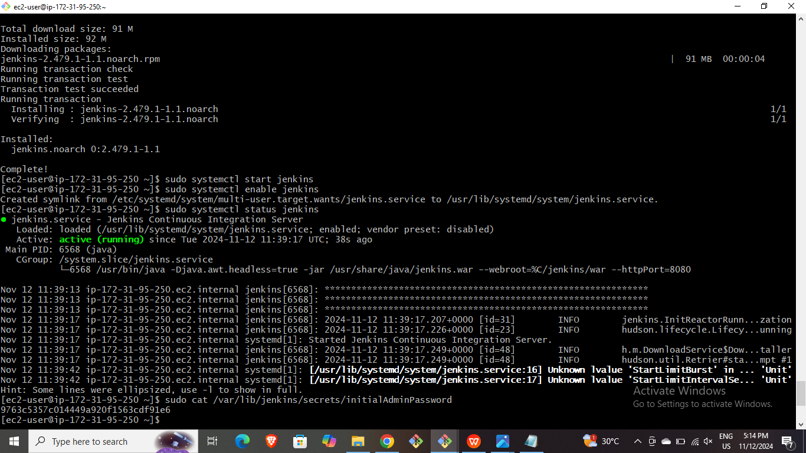

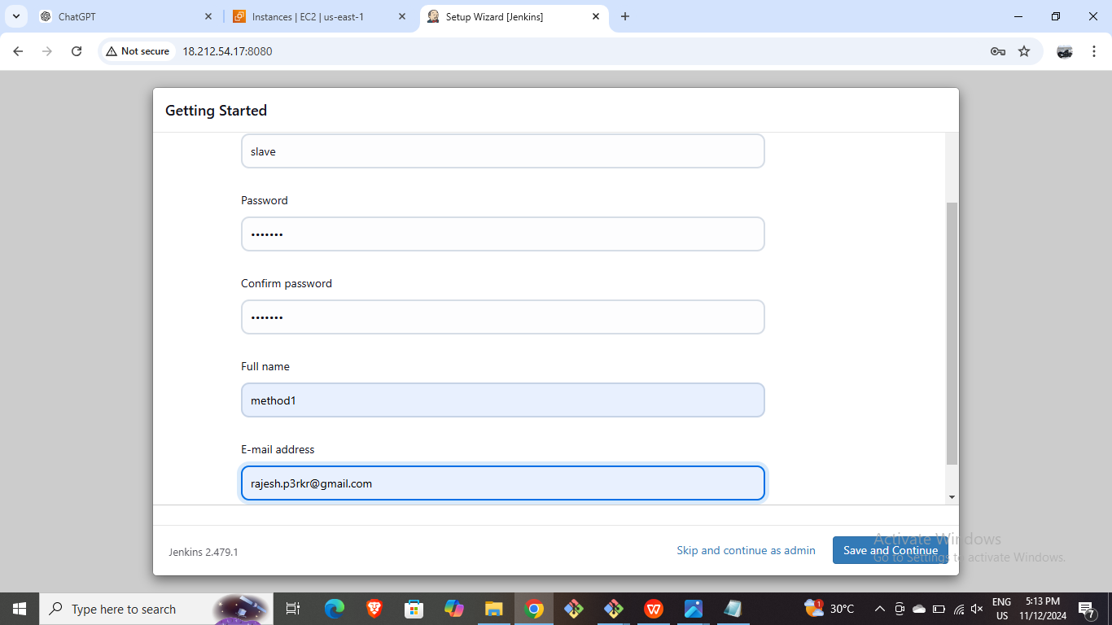

* Generate SSH keys through ssh-keygen command and copy the id_rsa.pub key.

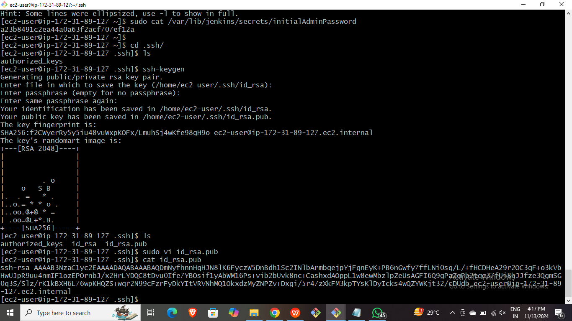

* Launch a instance for slave node.
* Connect it through CLI and install java-17 runtime and paste the ssh copied key of master in authorized keys of slave .

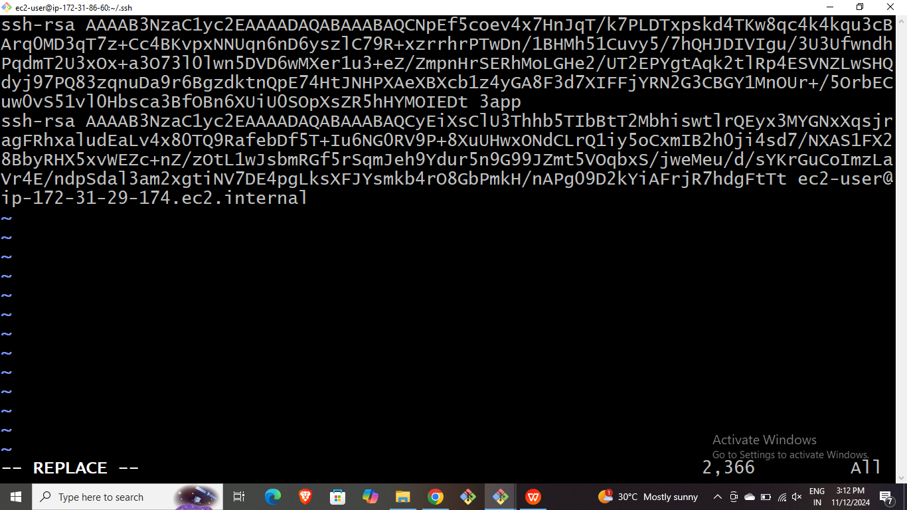

* Launch Jenkins and create a node for slave1 with required configuration and add it.

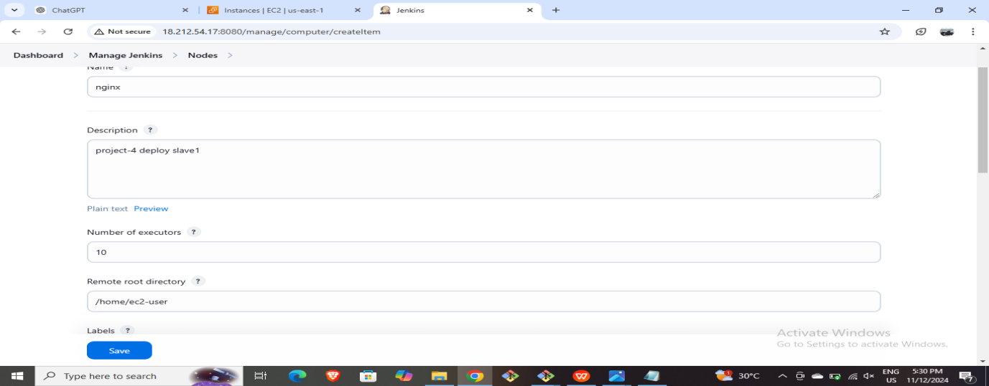

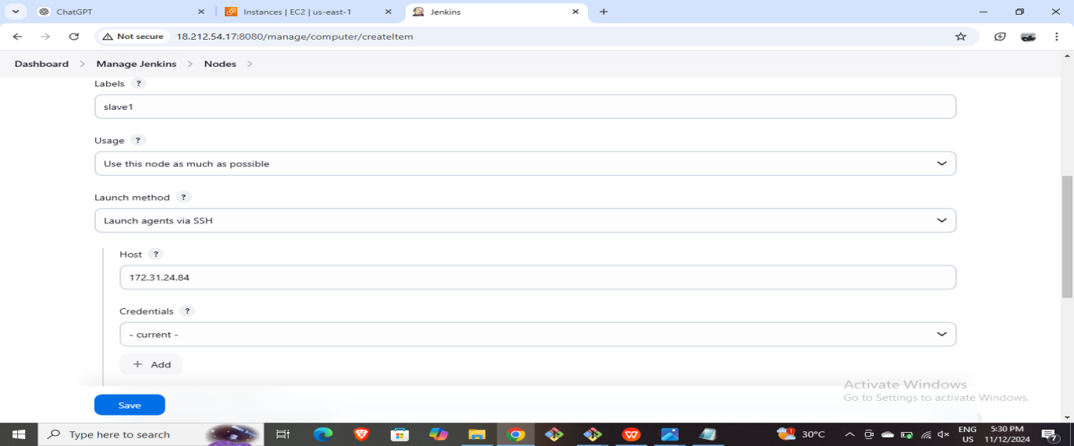

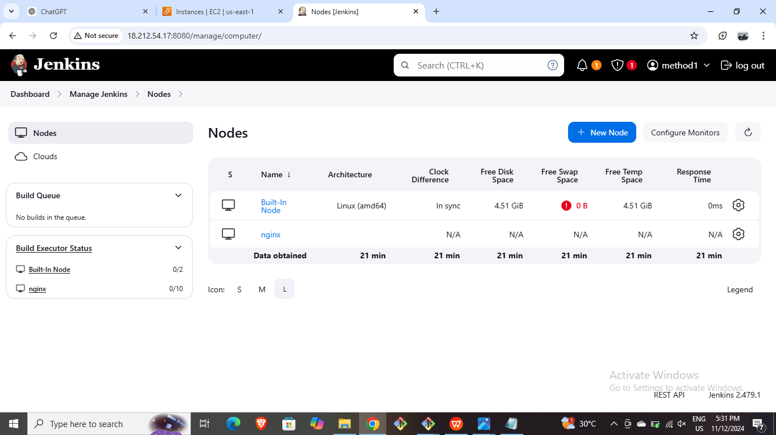

* Create a job and add the label of slave1 in restrict project option and give the commands for installing nginx in execute shell.

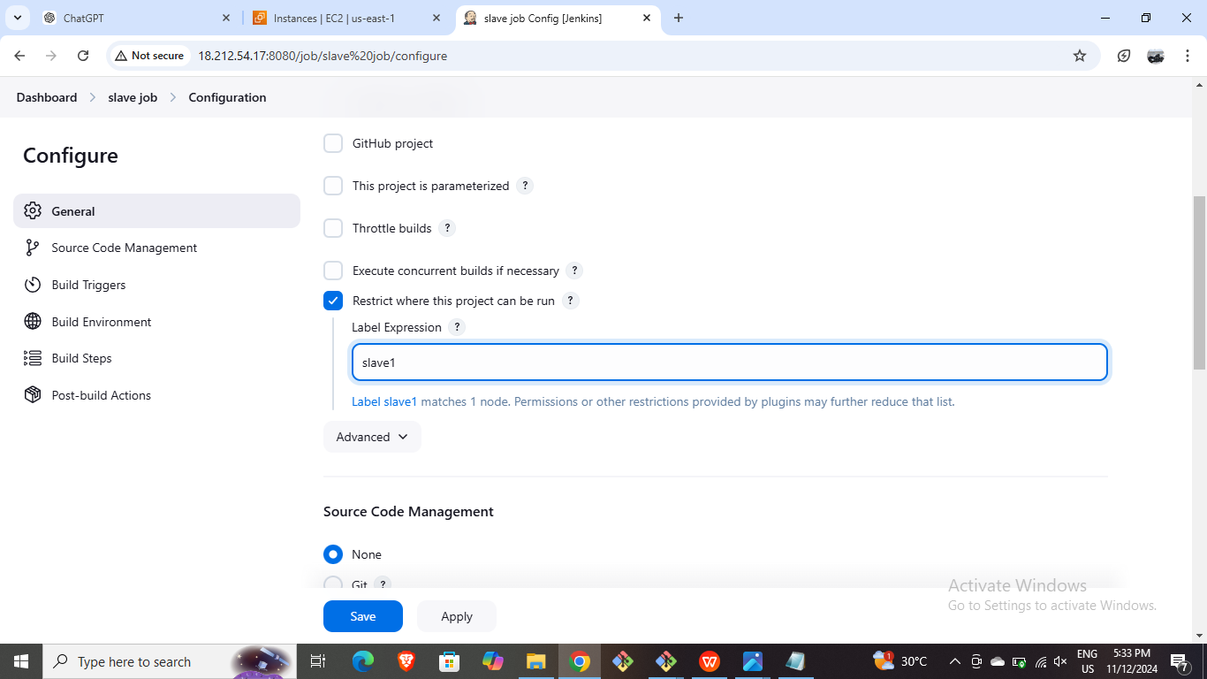

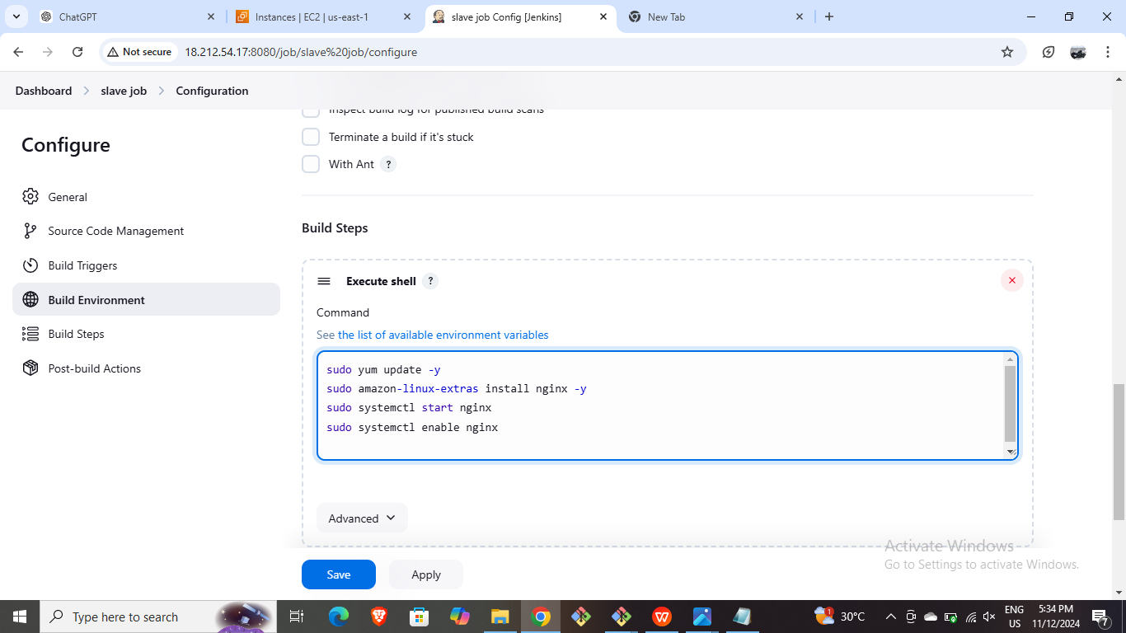

* Build the created job.
* Copy the public IP of slave1 and paste it on new tab.

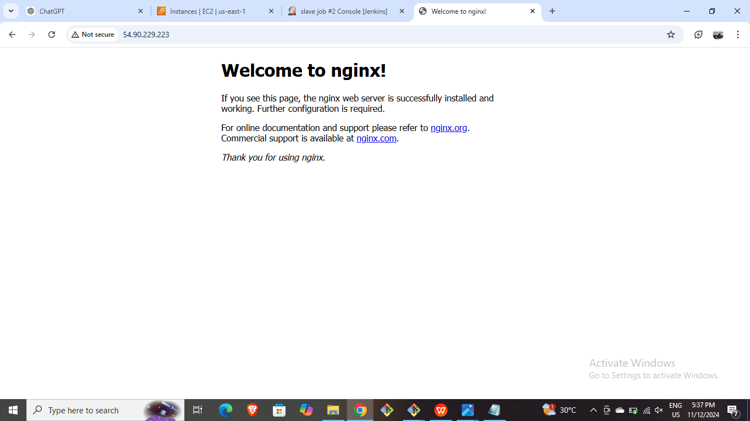

* **Slave 2: Installing HTTPS through Jenkins Master Slave Configuration.**
* Launch and instance for slave2 and make the required configurations.

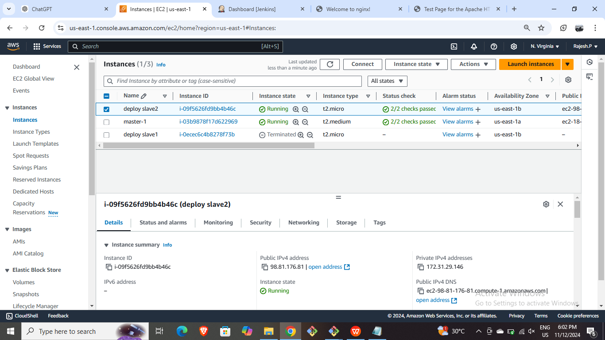

* Connect it through CLI and install java-17 runtime init and also paste the ssh key in authorized keys.
* Create a node for slave2 in Jenkins with required configurations



* Configure the slave job and give label2 .

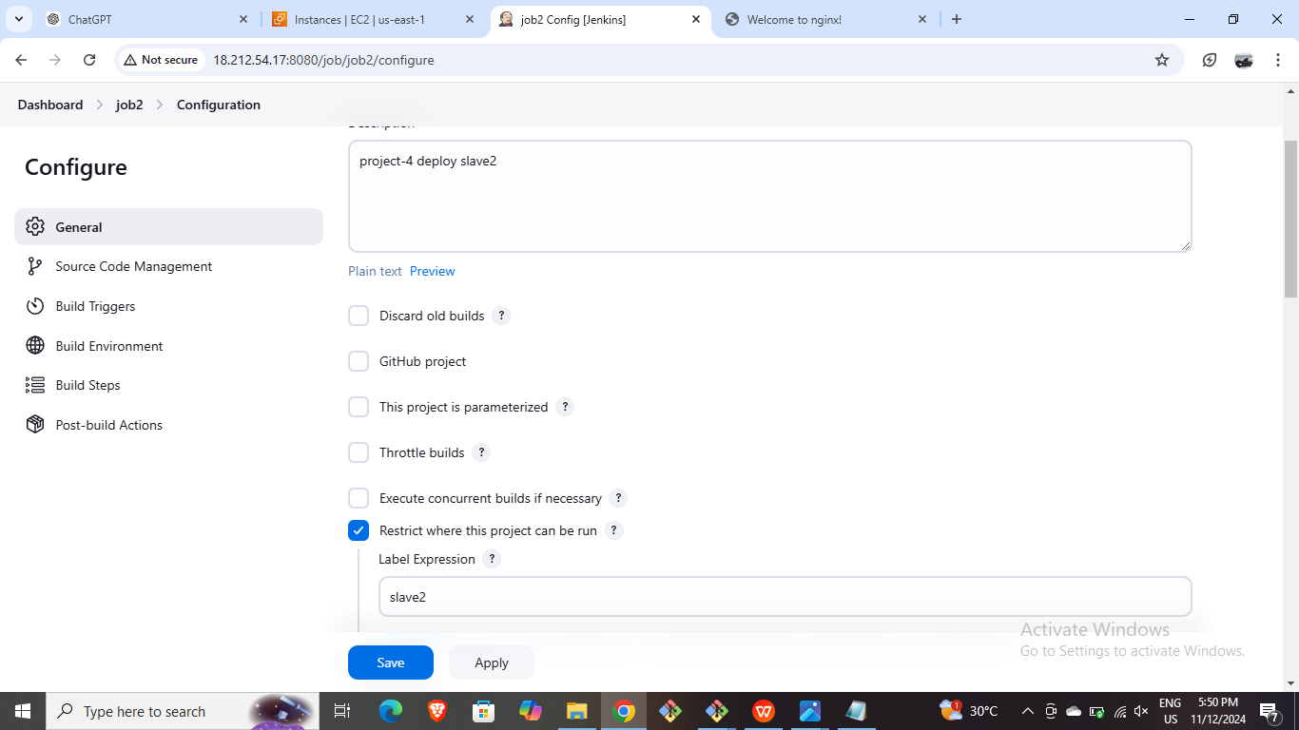

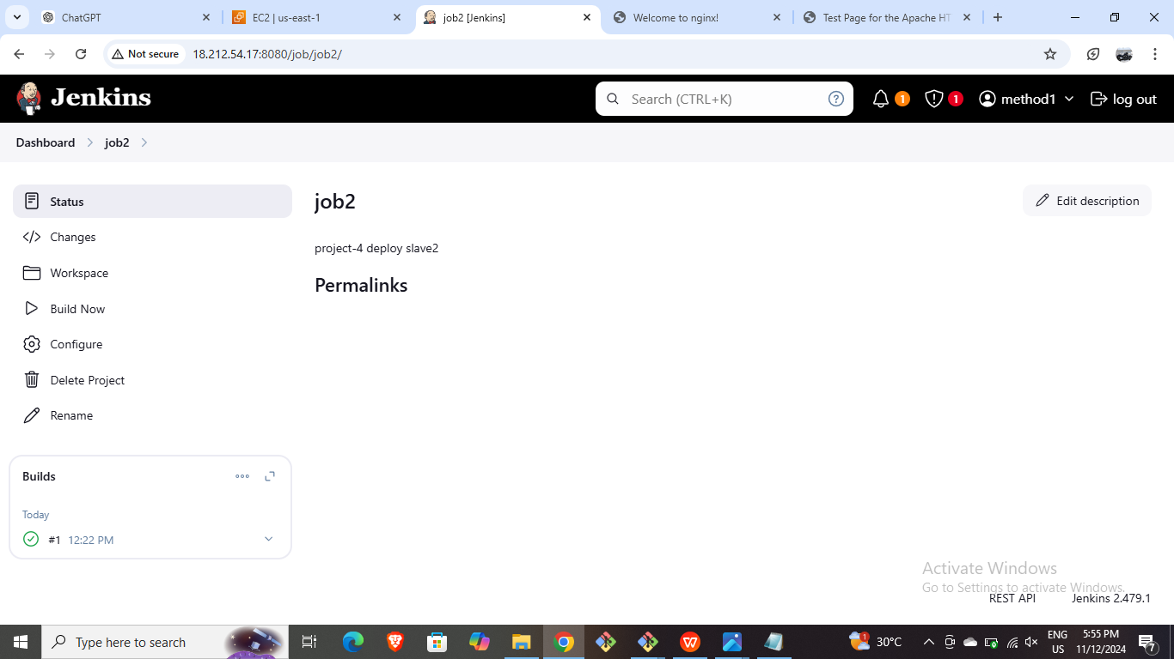

* Write the below script in the execute shell.

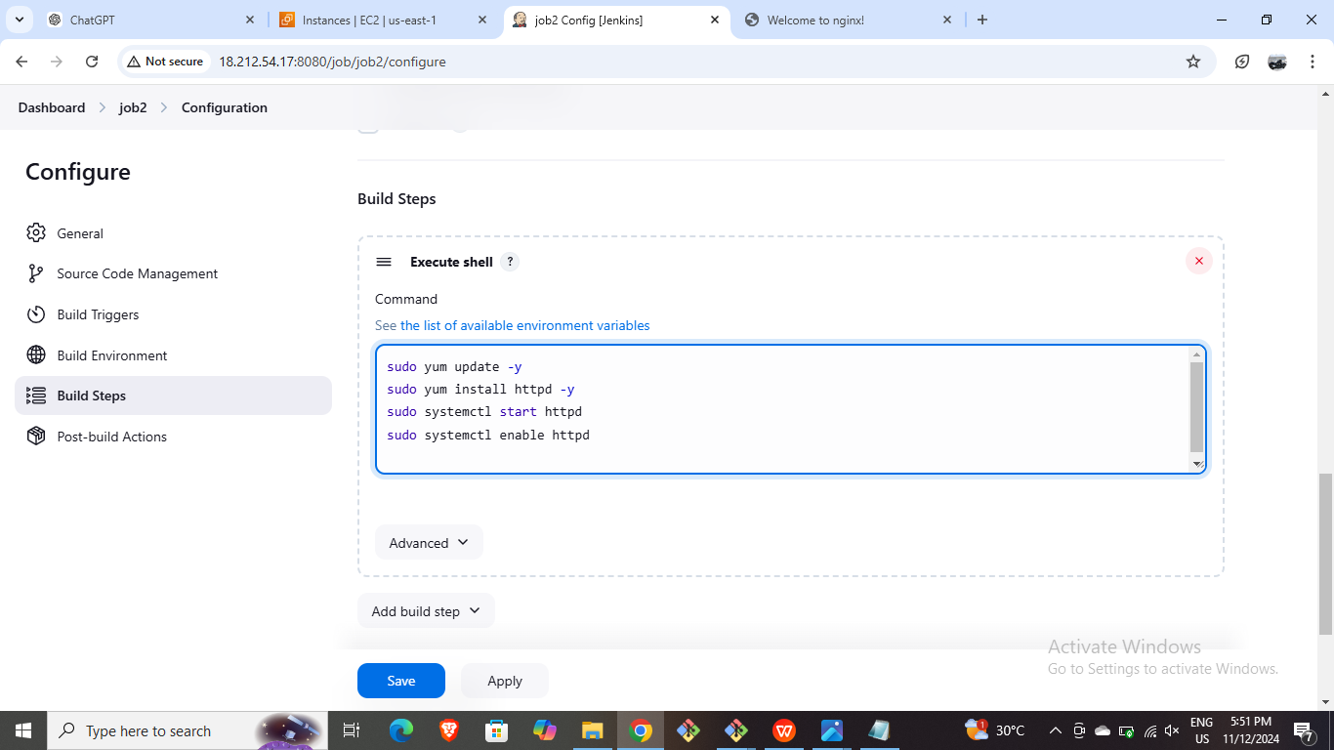

* Copy the public ip and paste it in new tab.

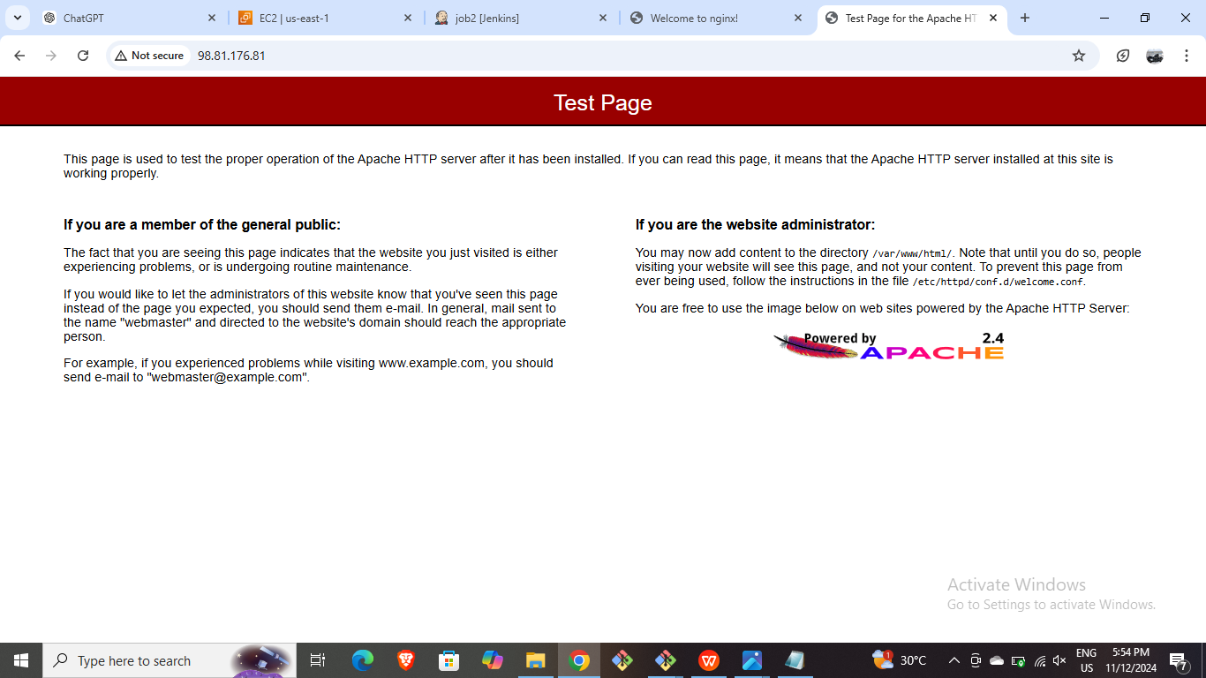

* **Slave 3: Installing TomCat through Jenkins Master Slave Configuration.**
* Launch and instance for Slave3.

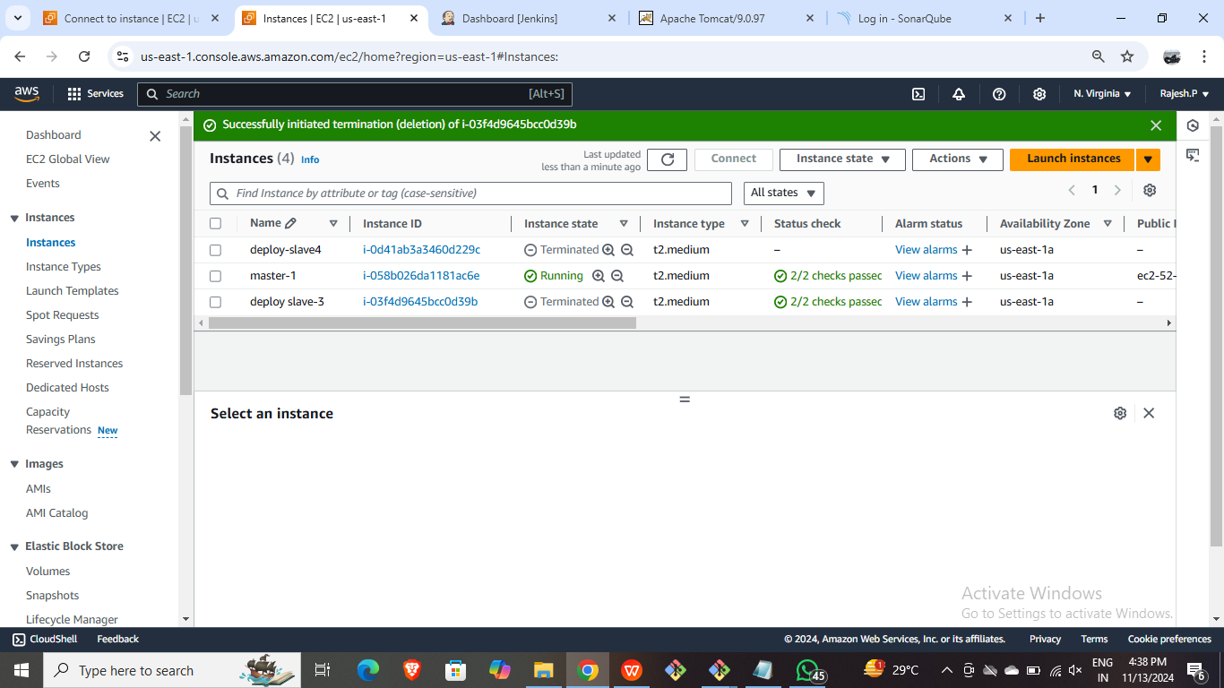

* Connect it through CLI and install java-17 as runtime and give ssh keys in authorized keys.

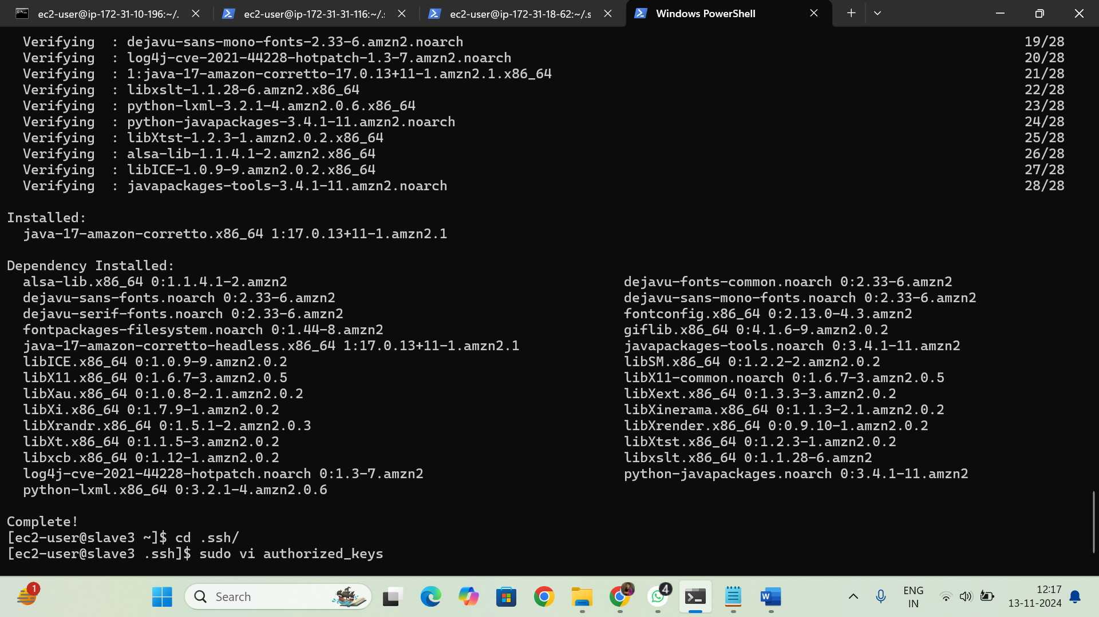

* Create a node for slave3 with required configuration.

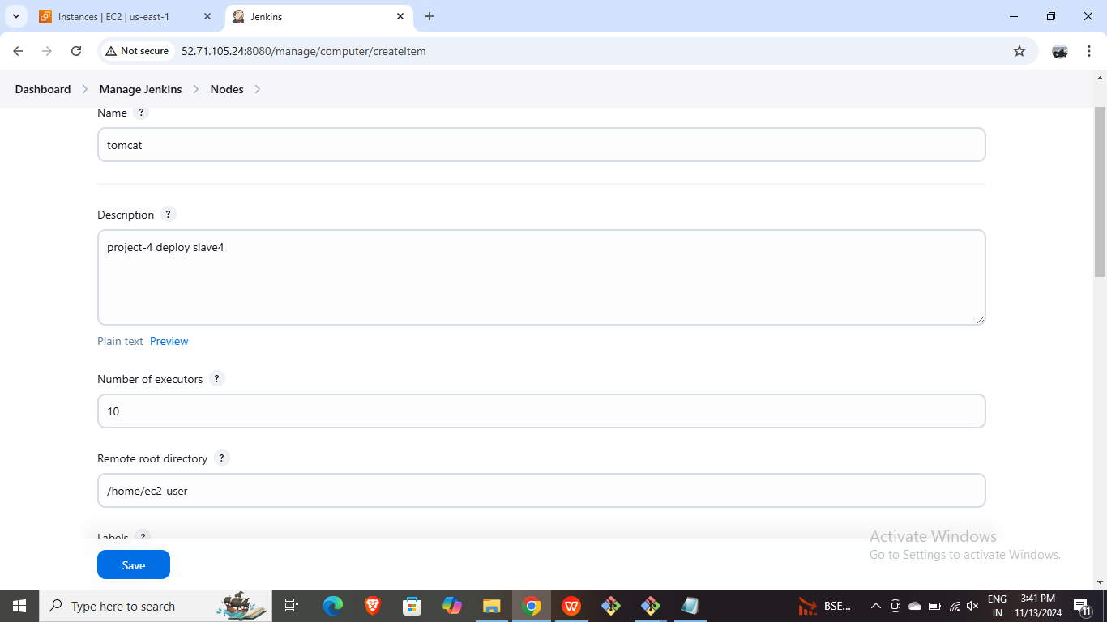

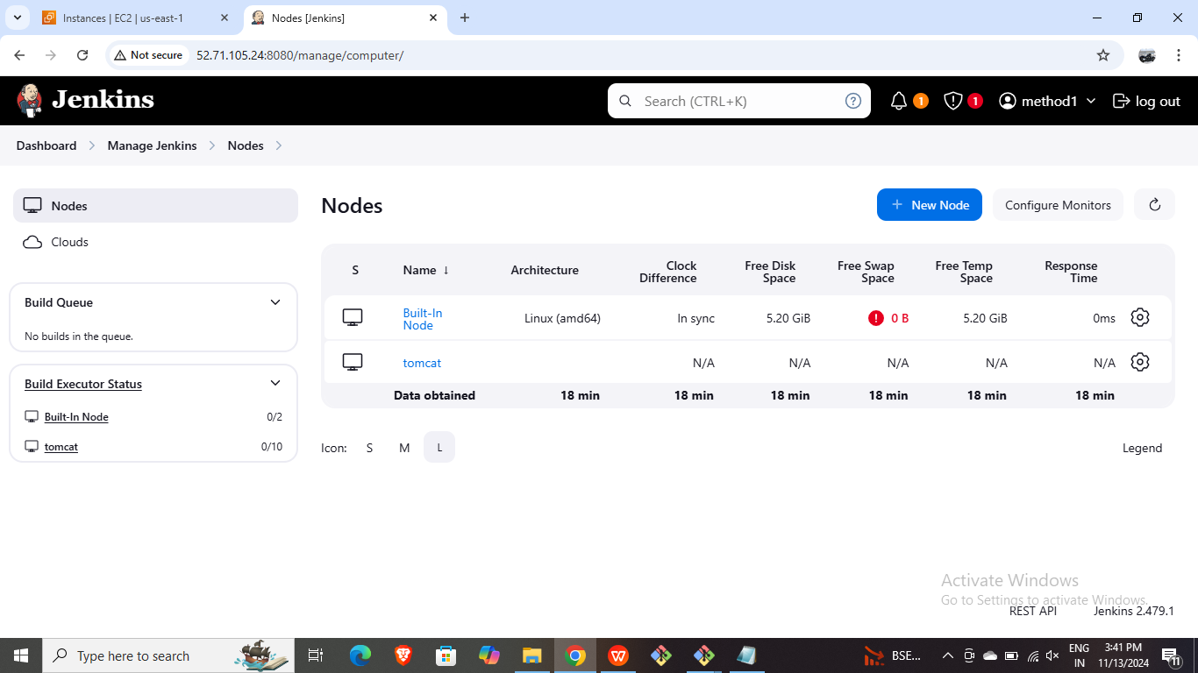

* Configure the job and give it label =3 and command to unstall apche tomcat in execute shell.
* 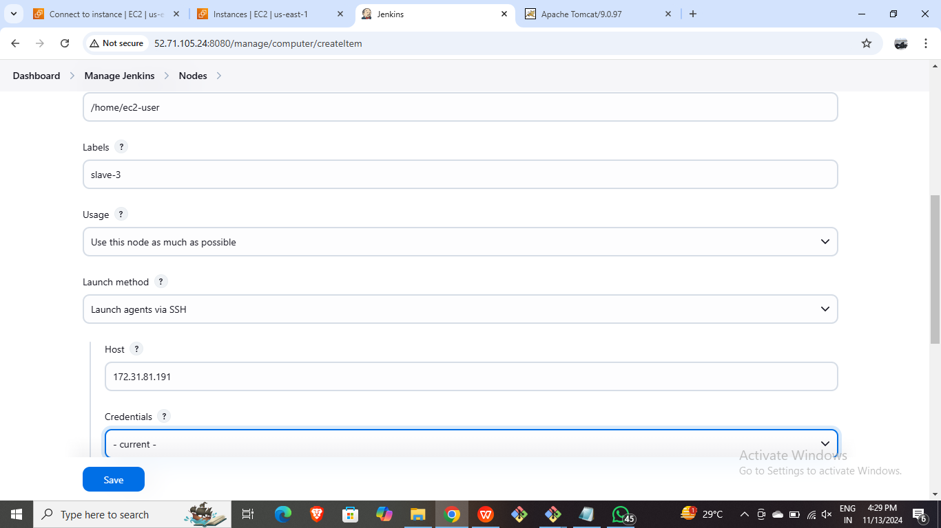

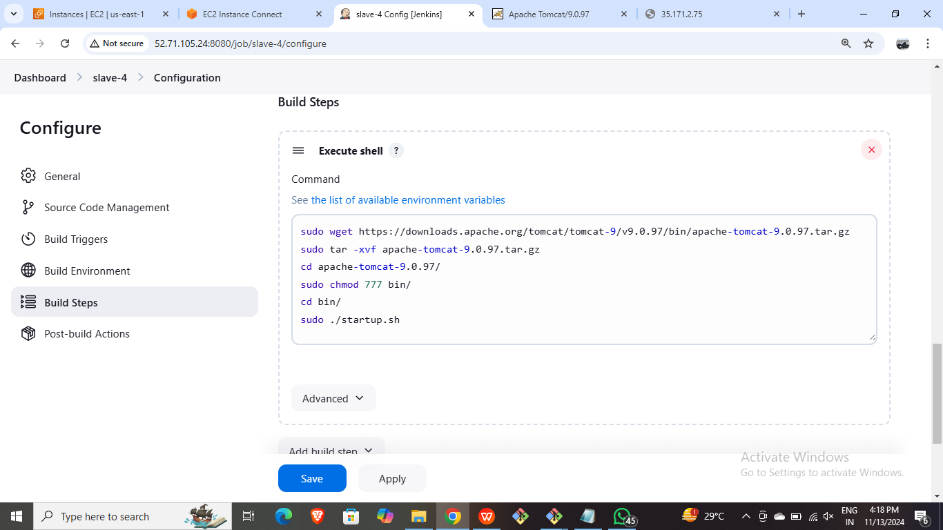

* Copy and browse the public ip of the Slave3.

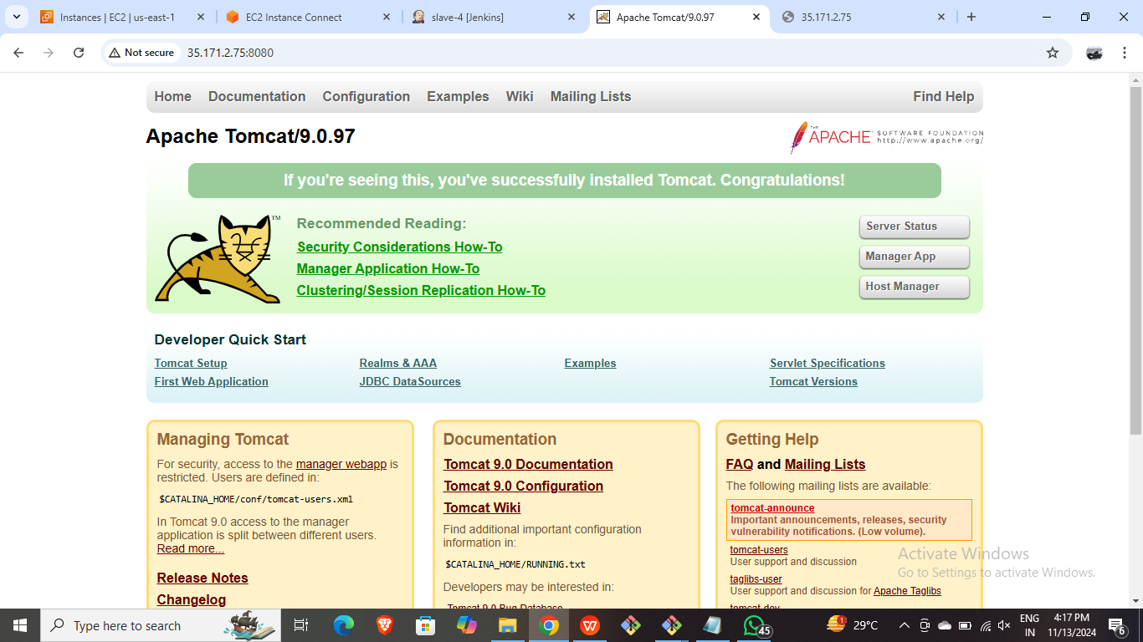

* **Slave 4: Installing HTTPD and NGINX through Jenkins Master Slave Configuration.**
* Launch an ec2 instance for slave 4

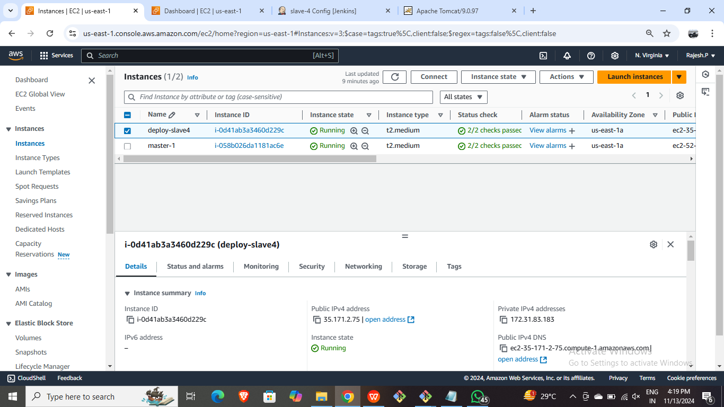

* Connect it with CLI and install java in it.

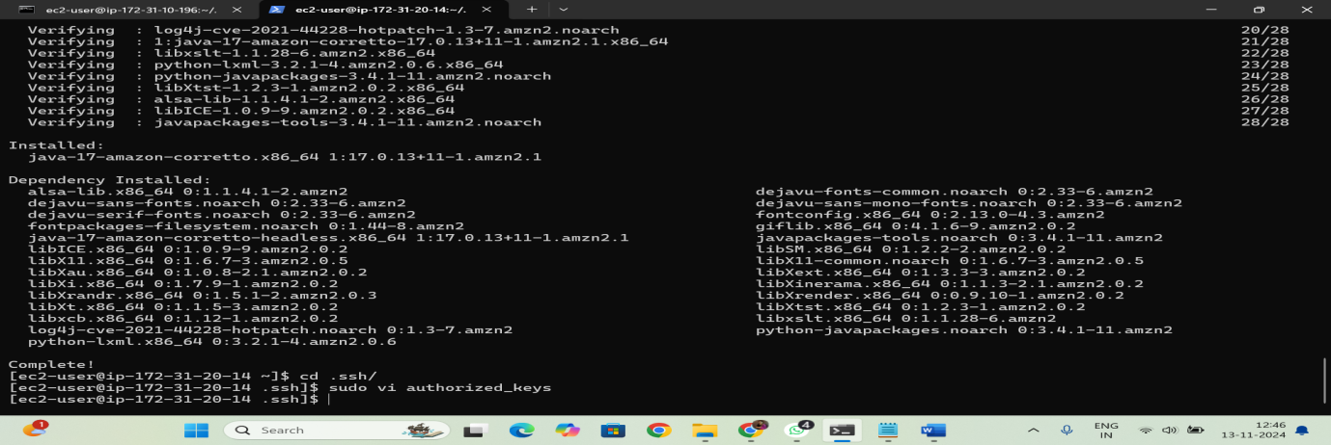

* Create a node with required configurations in Jenkins.

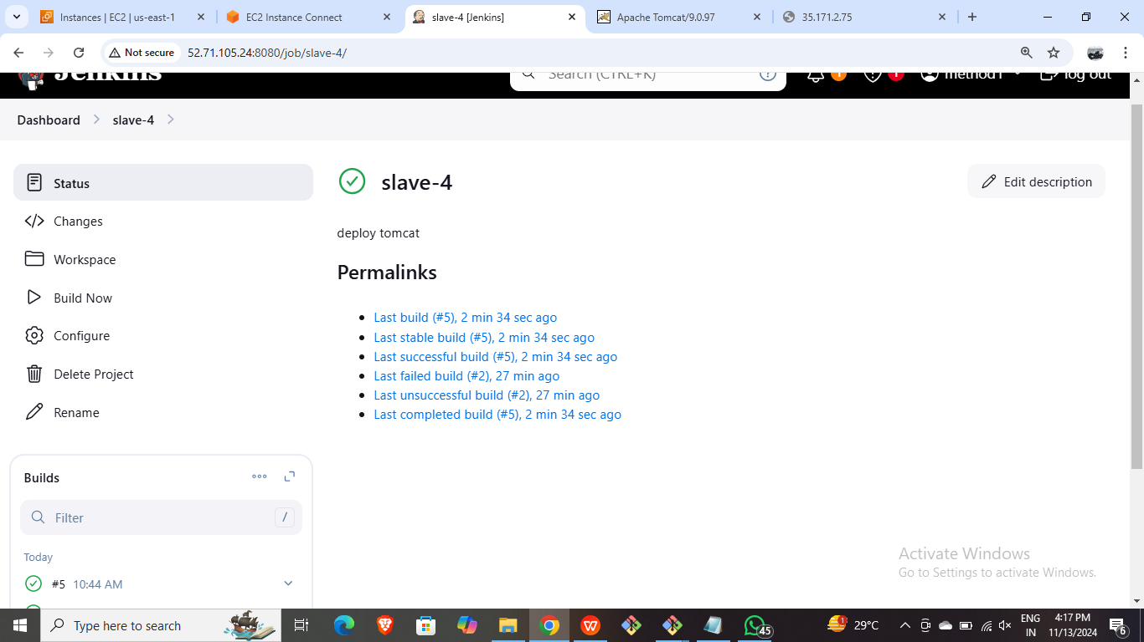

* Create a new job with below configurations.



* Write the below code in Execute shell of the job.

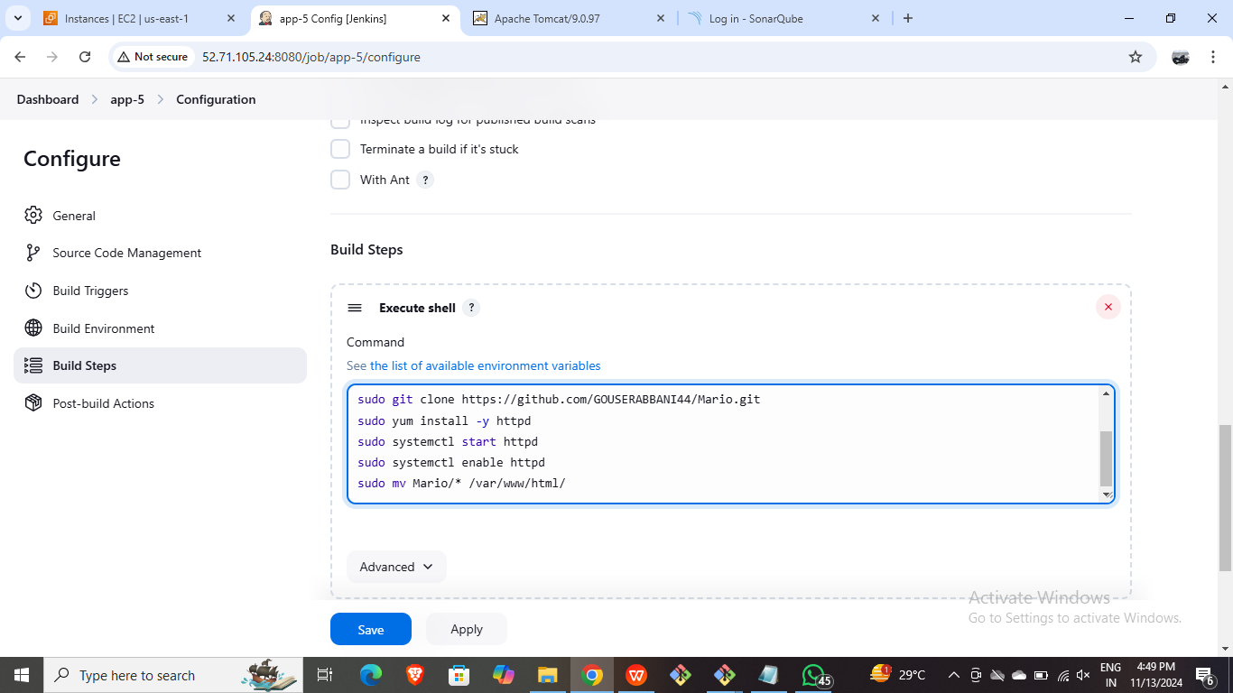

* Copy the public IP of the instance and browse it in new tab.

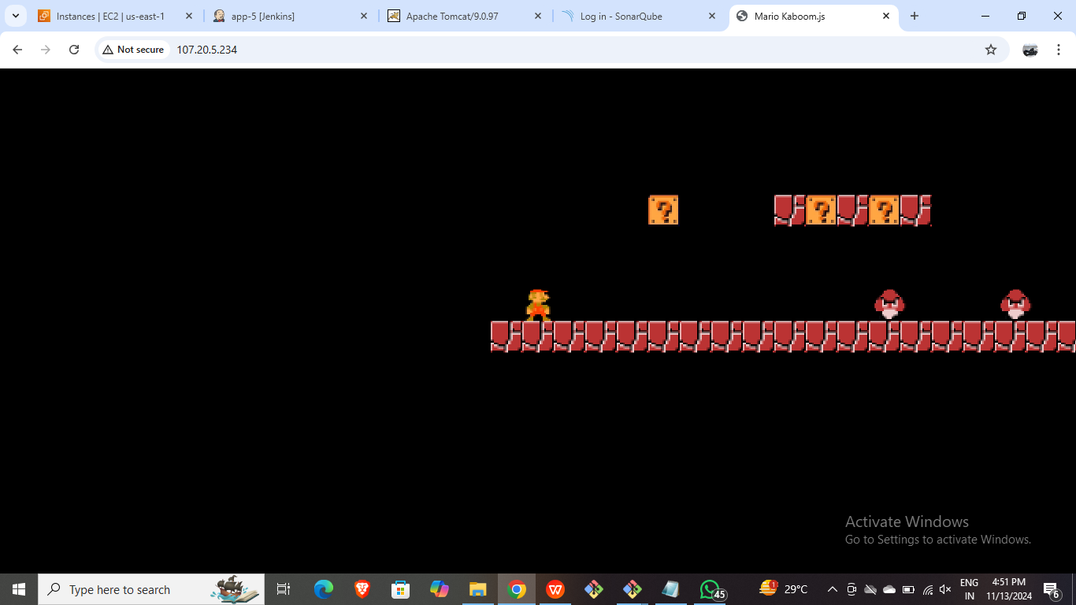

* **Slave 5: Installing SonarQube through Jenkins Master Slave Configuration.**
* Launch an EC2 instance for slave 5

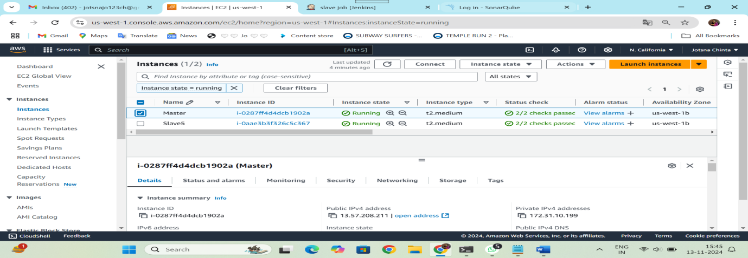

* Connect it through CLI and install java-17 as runtime and give ssh key.

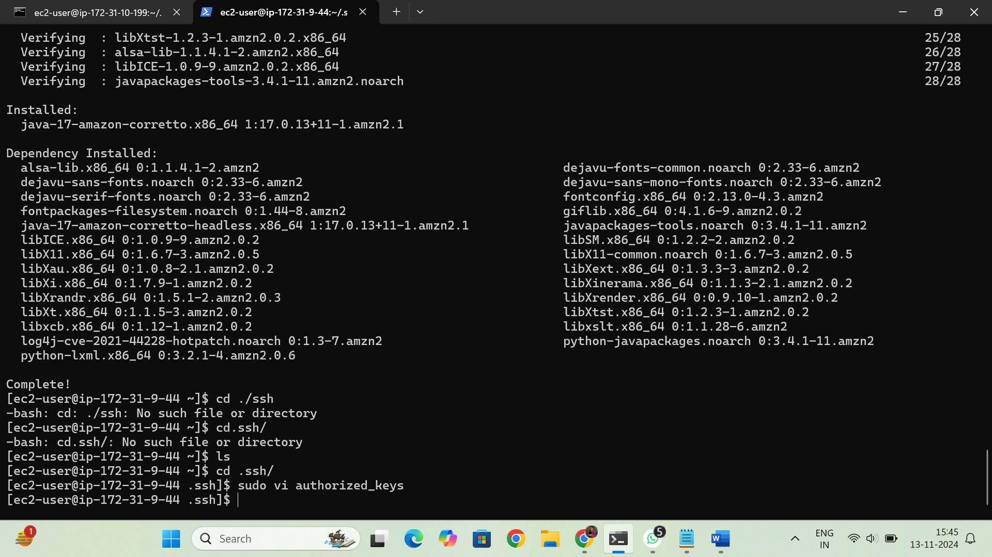

* Create a new node with required configurations.

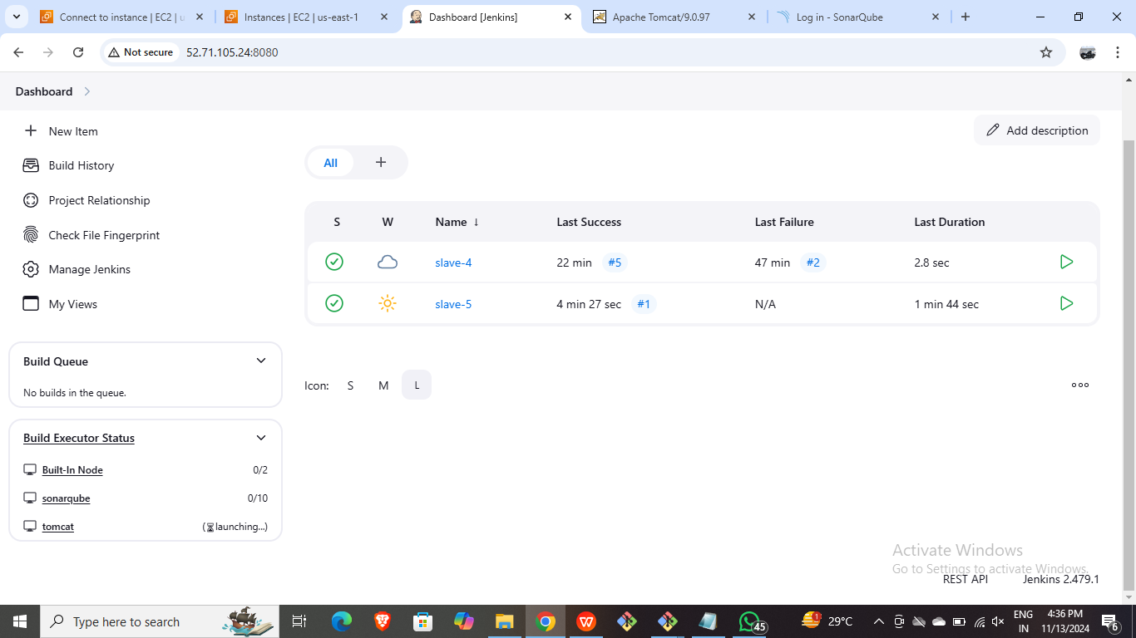

* Create a new job with restrict labels and script on execute shell.

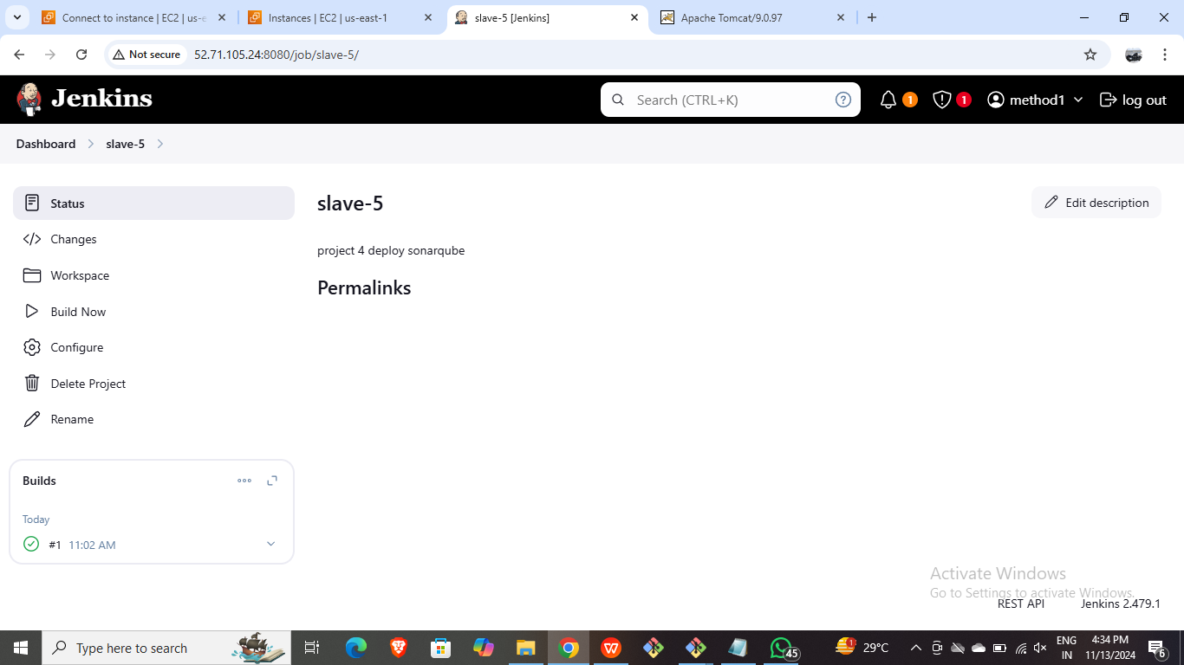

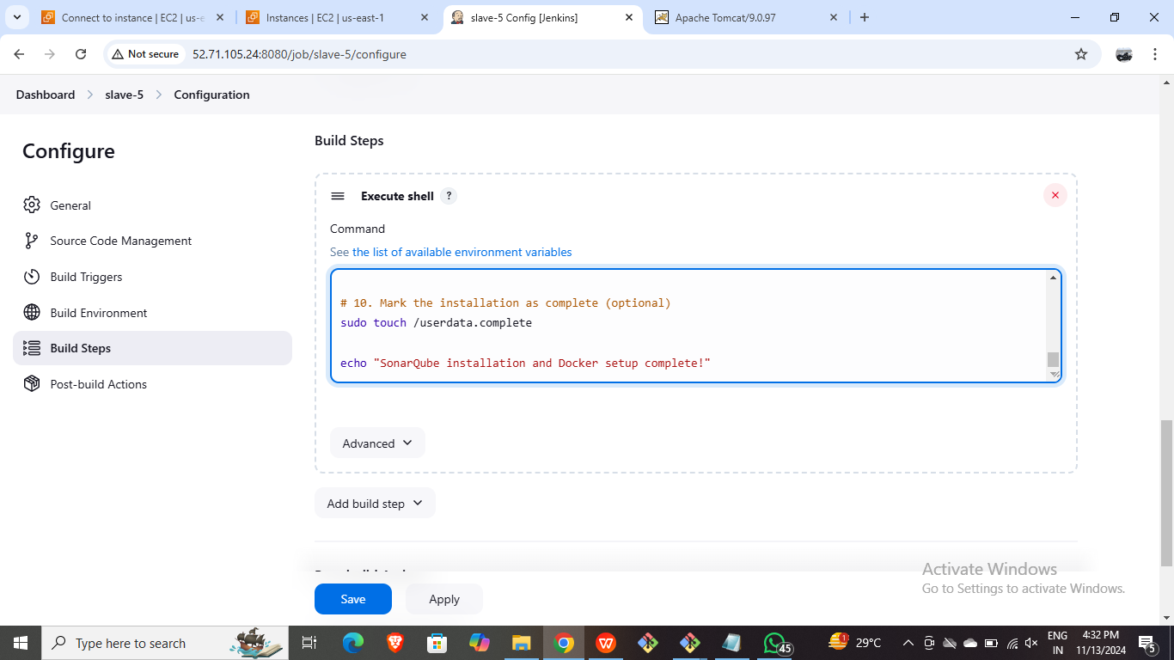

* Copy and browse the public IP of the slave5 server.

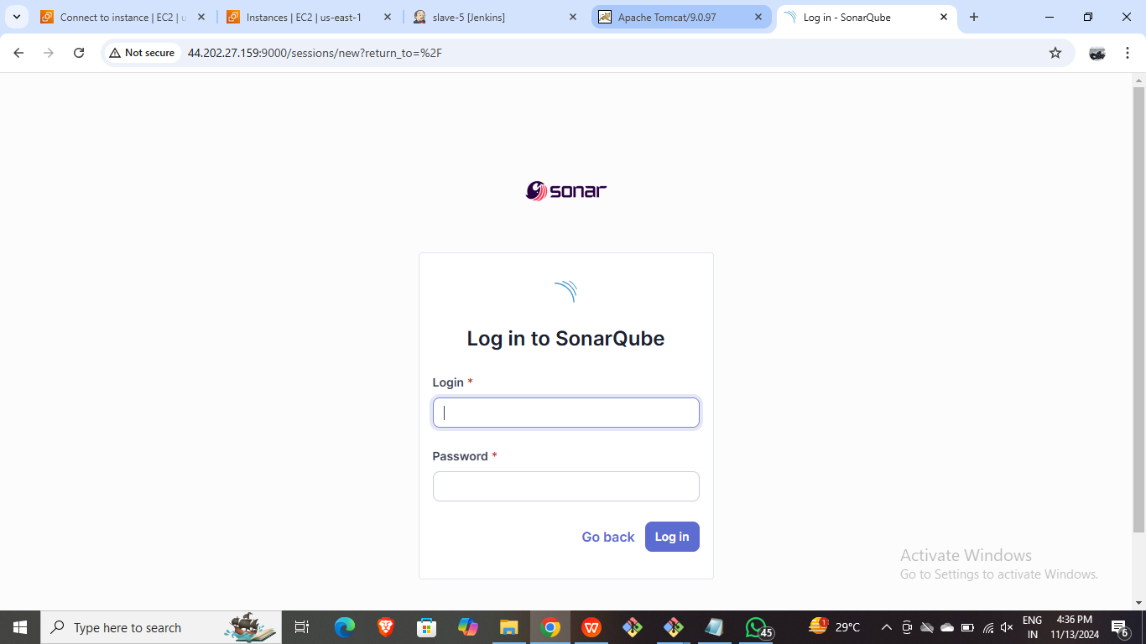

Method 2:

* Create one master and five slave nodes and deploy python web applications through manually (Slave-1), bash script (Slave-2), terraform (Slave-3) and deploy java-based application through manually (Slave-4) and bash script (execute shell) (Slave-5).
* Slave 1: deploy python web applications through manually
* Create an EC2 instance for Master.

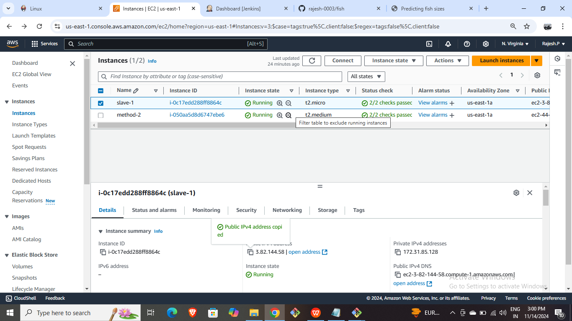

* Connect it through CLI and install Jenkins in it and generate ssh keys in it.

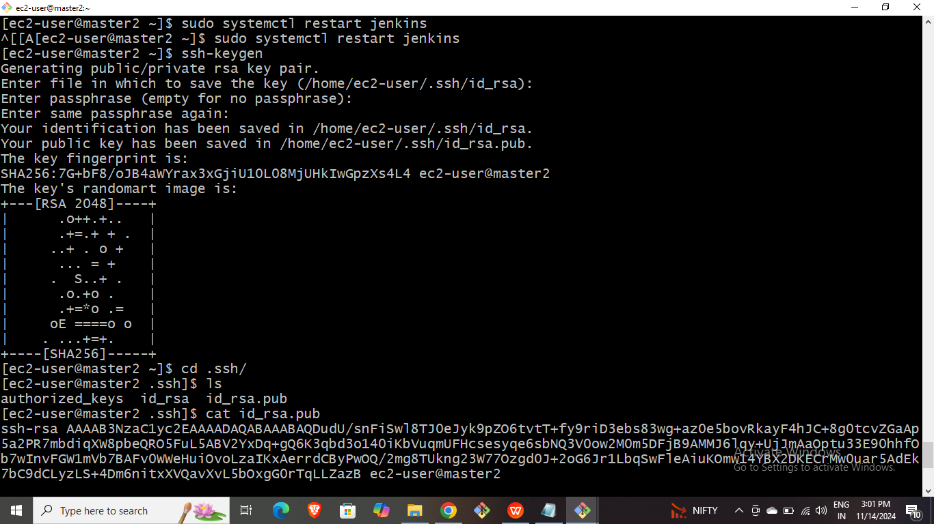

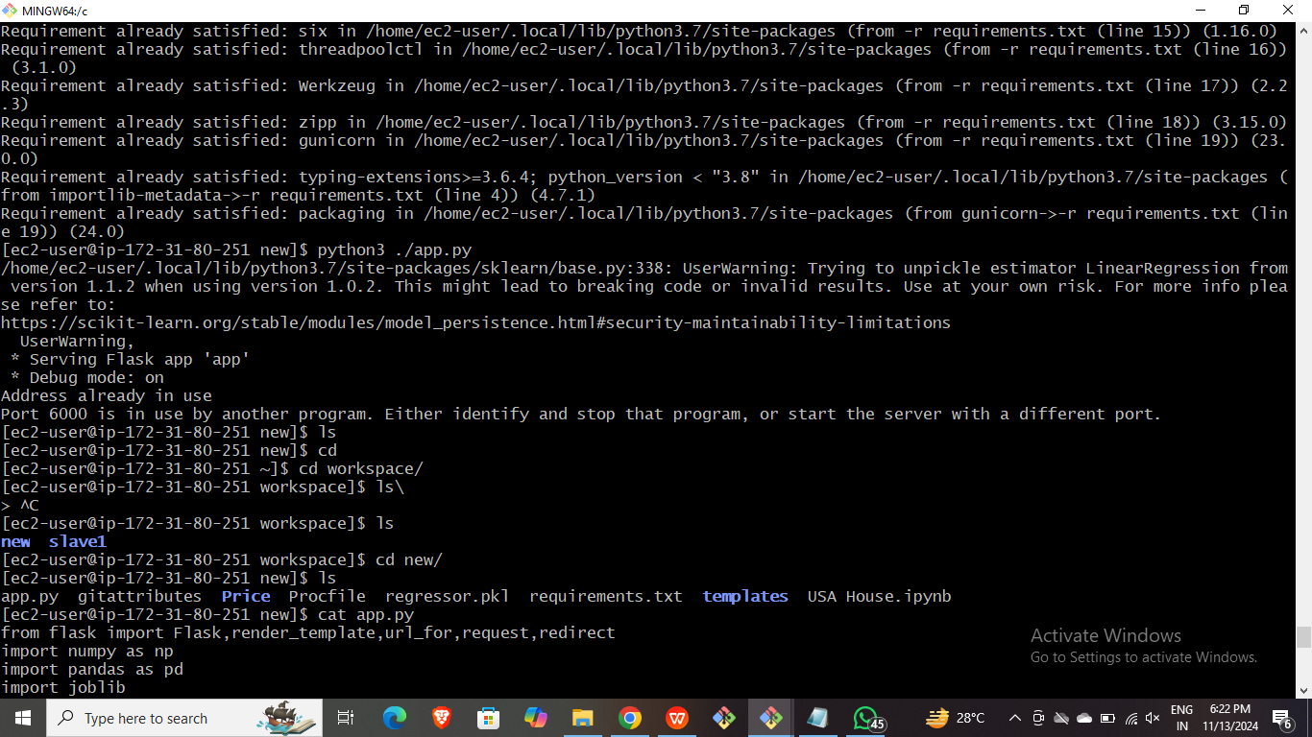

* Launch AWS instance for Slave1.

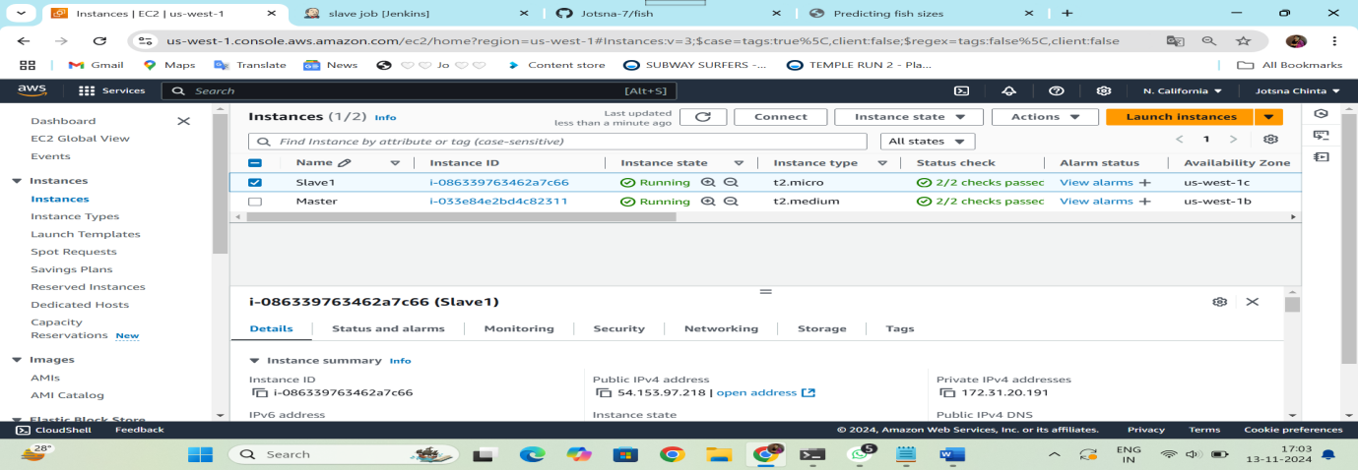

* Connect it through CLI and install java-17 as runtime and give ssh key.

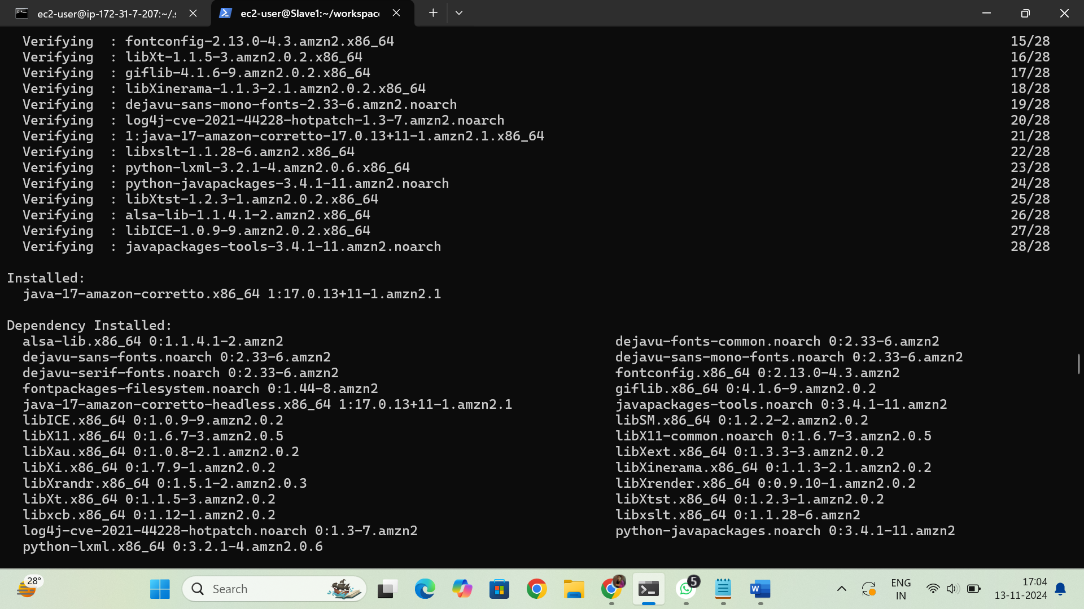

* Create a new node with required configurations.

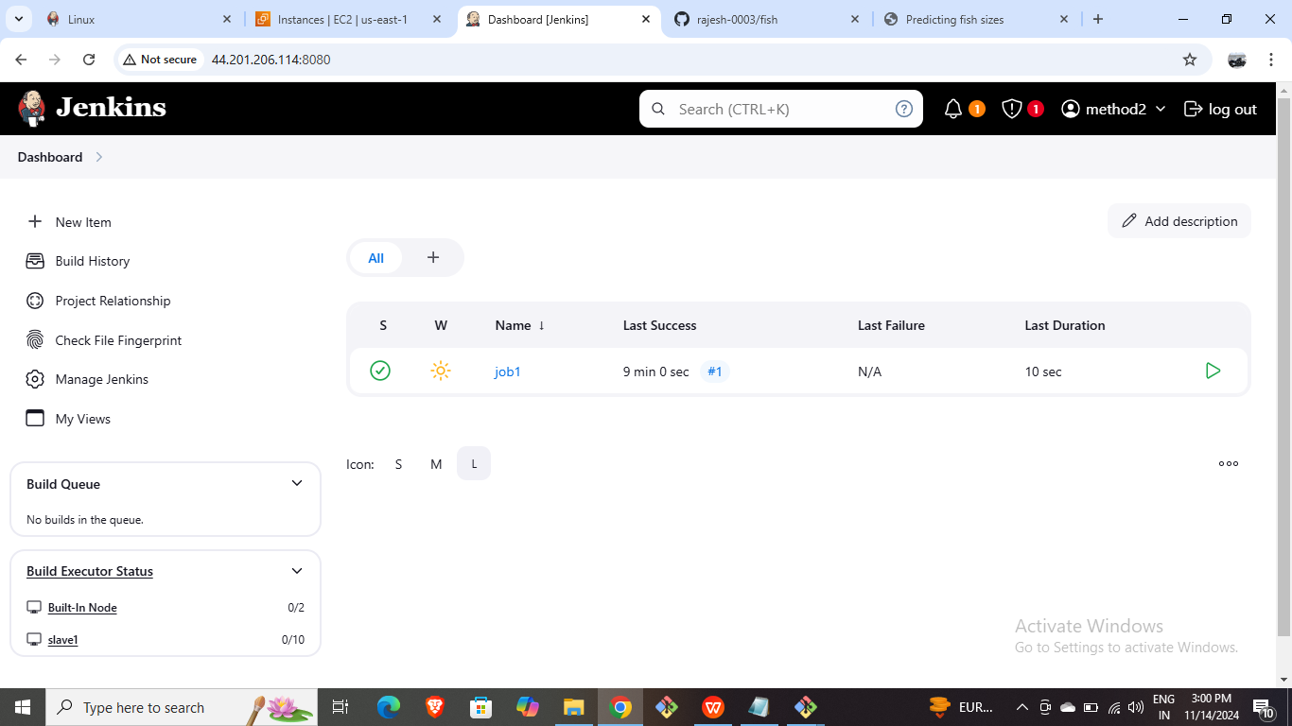

* Create a new job with restrict labels and script on execute shell.
* Write the below script in execute shell of Jenkins.
* Install python and pip3 and run them in CLI manually as shown below.

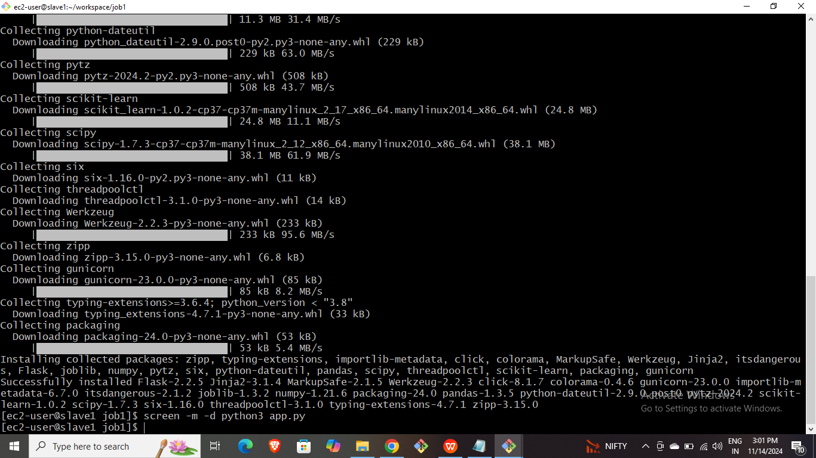

* Copy and browse the public IP of the instance.

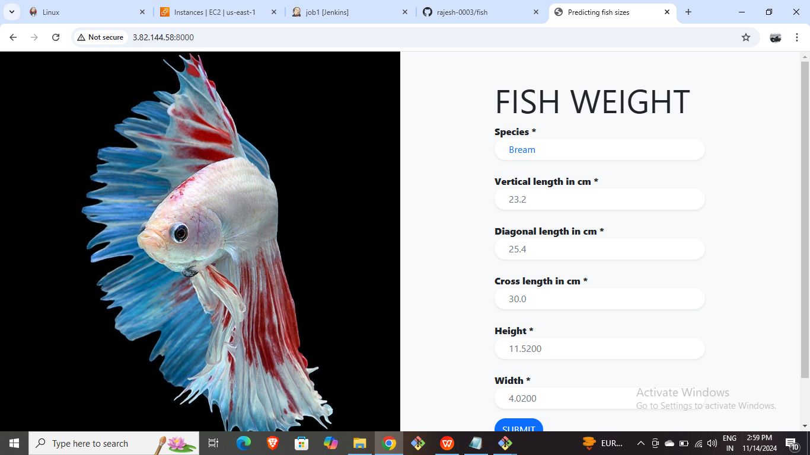

Slave 2: Deploying Python web application using Bash Script.

* Launch an AWS EC2 instance for Slave2.

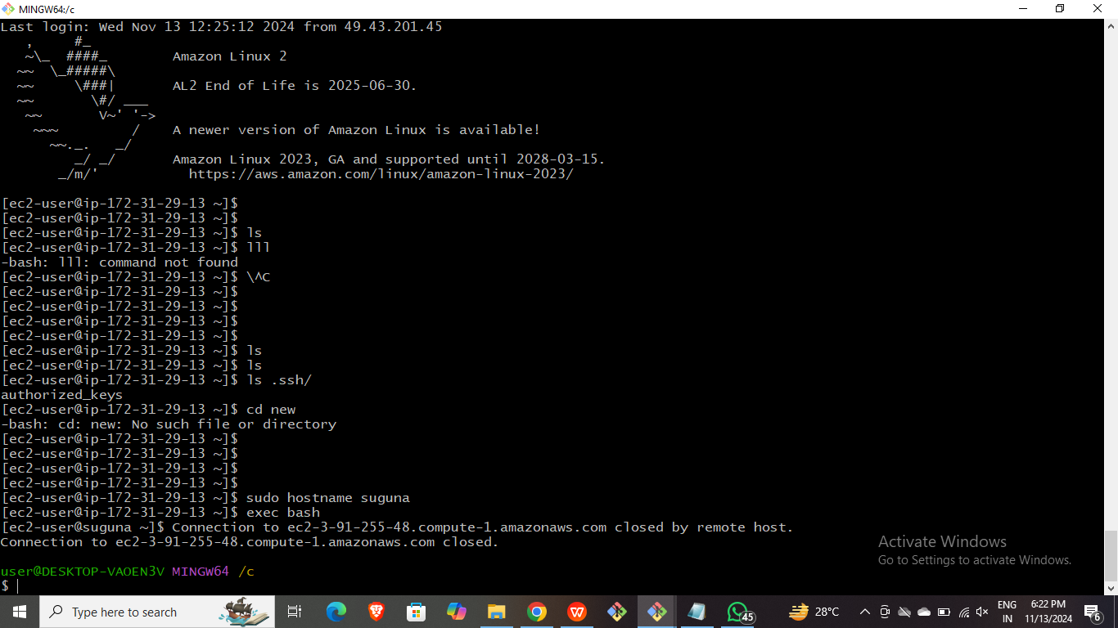

* Connect it with CLI and install java-17 in it.
* Create an Jenkins node for Slave2 with required configurations.

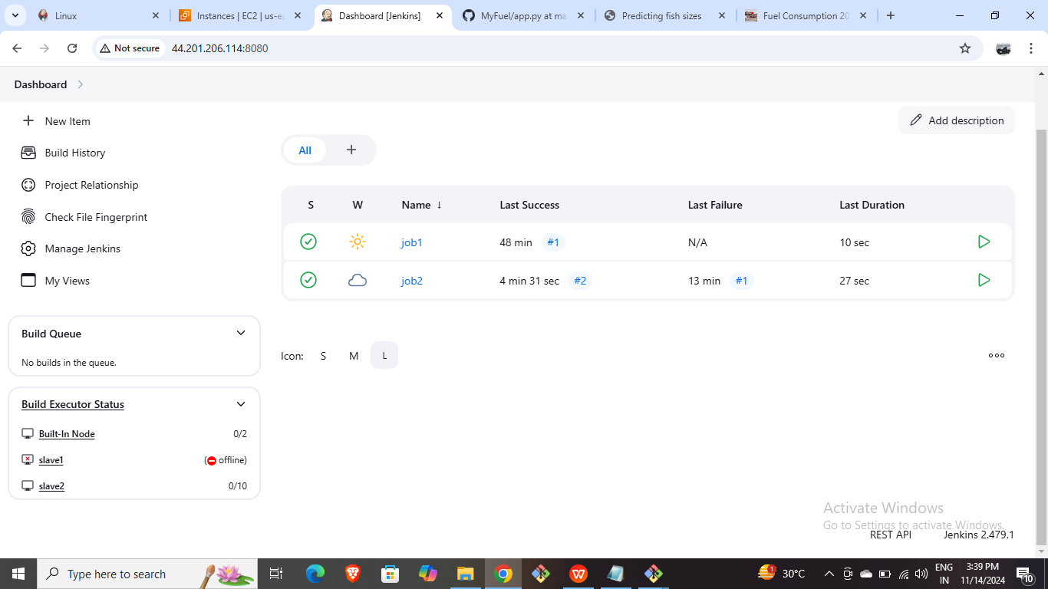

* Create a new job with restrict labels and script on execute shell.

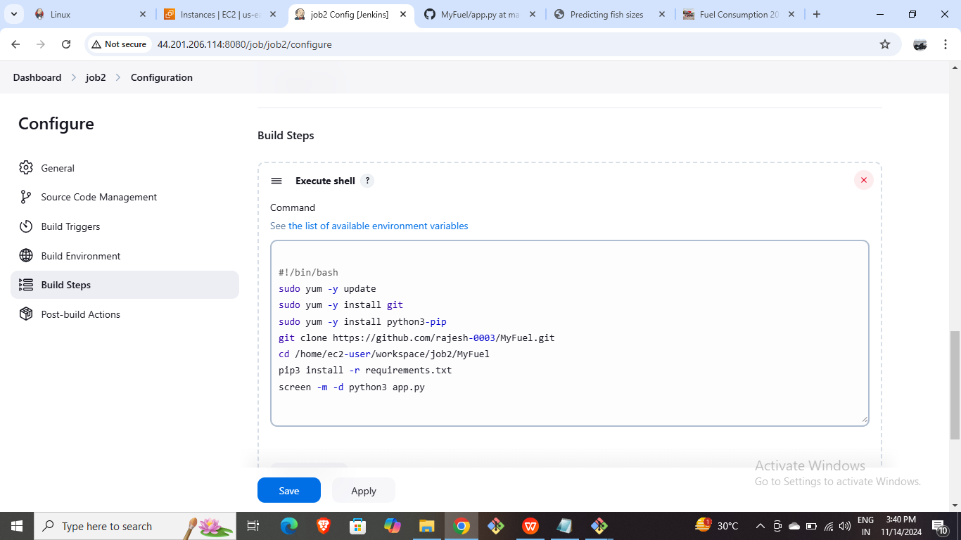

* Build the job and browse the public IP of the Instance.

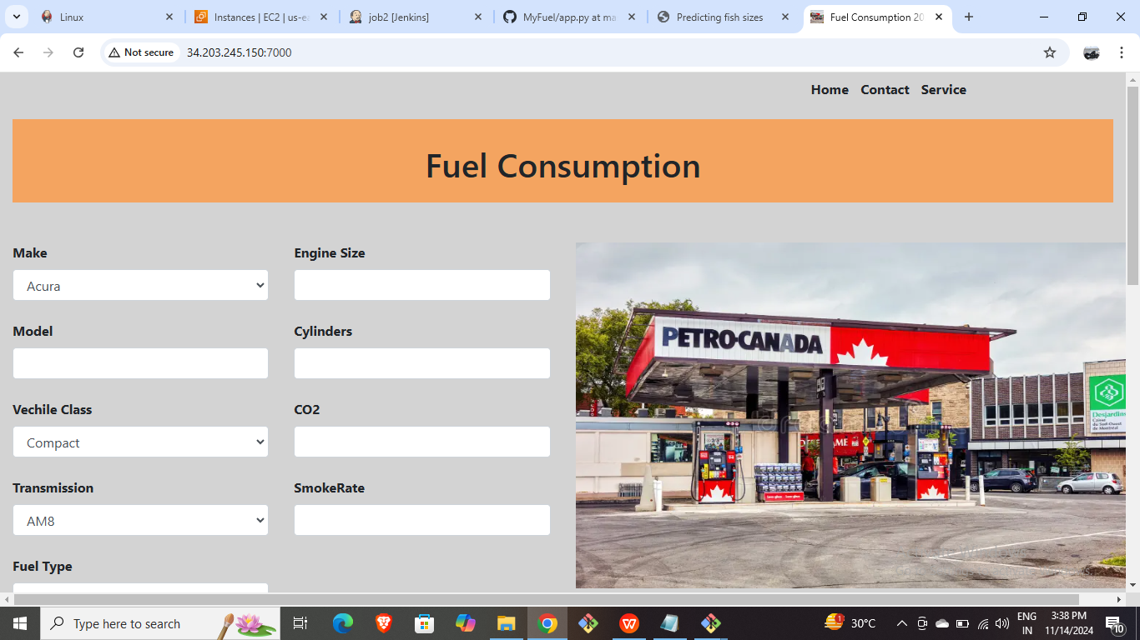

* Slave 3: Deploying Python web application using Terraform.
* Launch an EC2 Instance for Slave3.

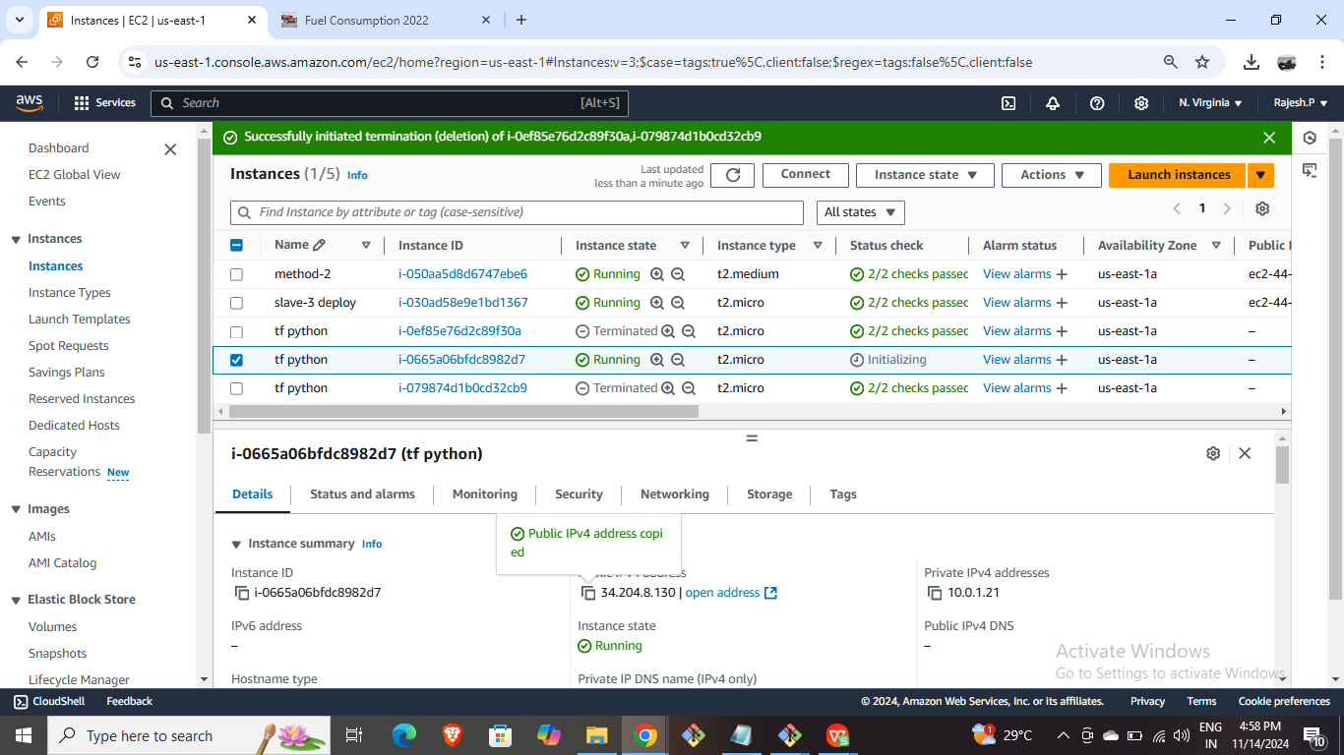

* Connect it through CLI and install Java-17 in it.
* Create a Jenkins node for Slave3 using required Cnfigurations.

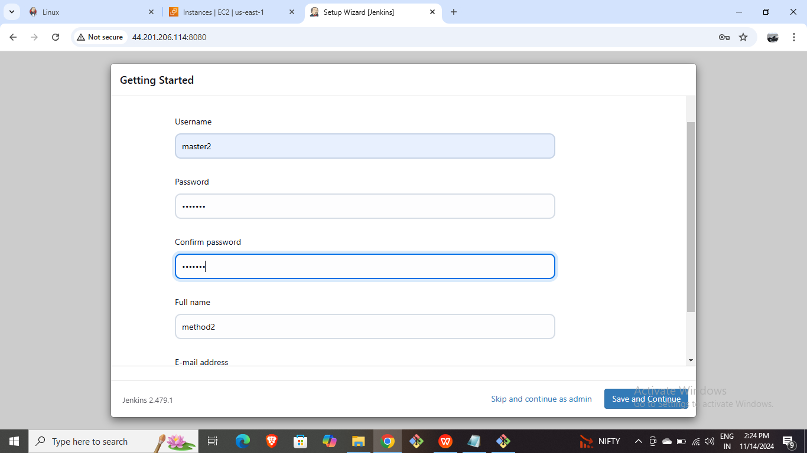

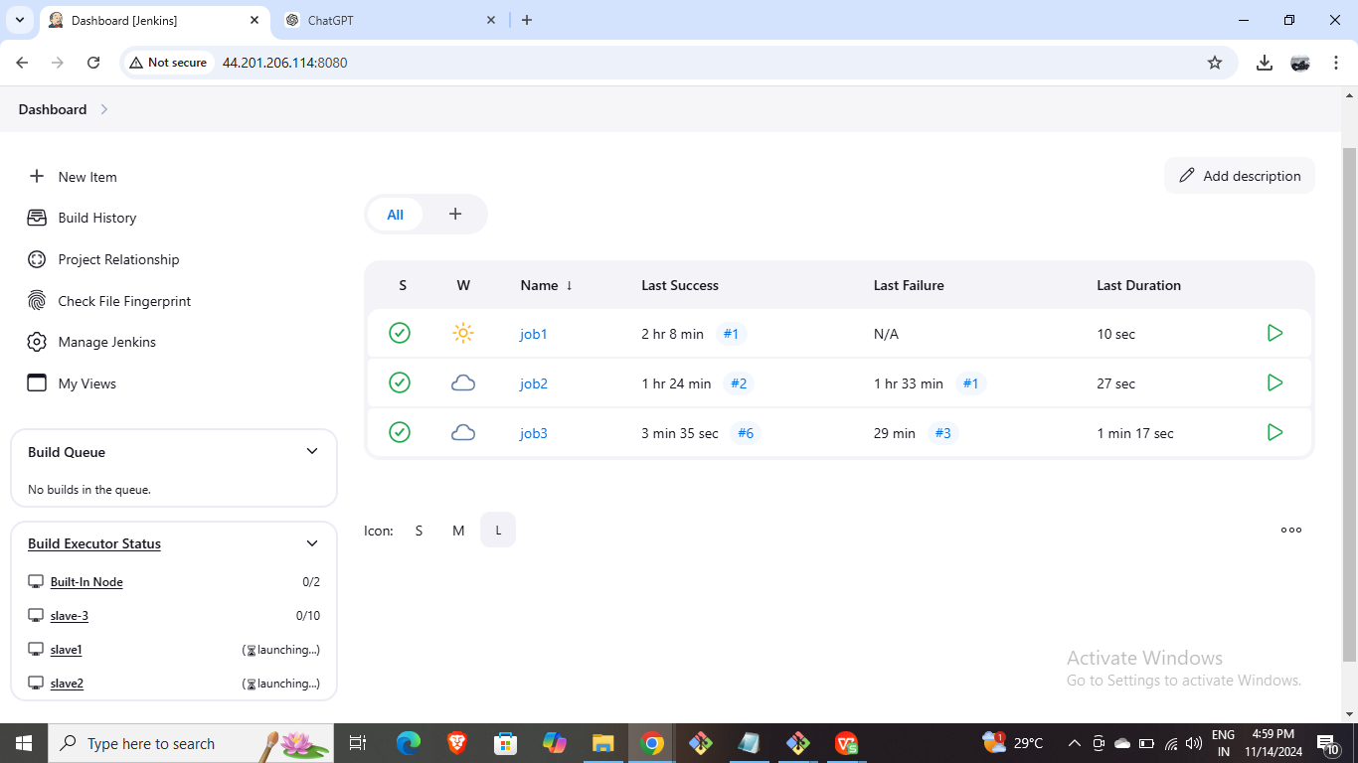

* Create a new job with restrict labels.
* Provide AWS Credentials

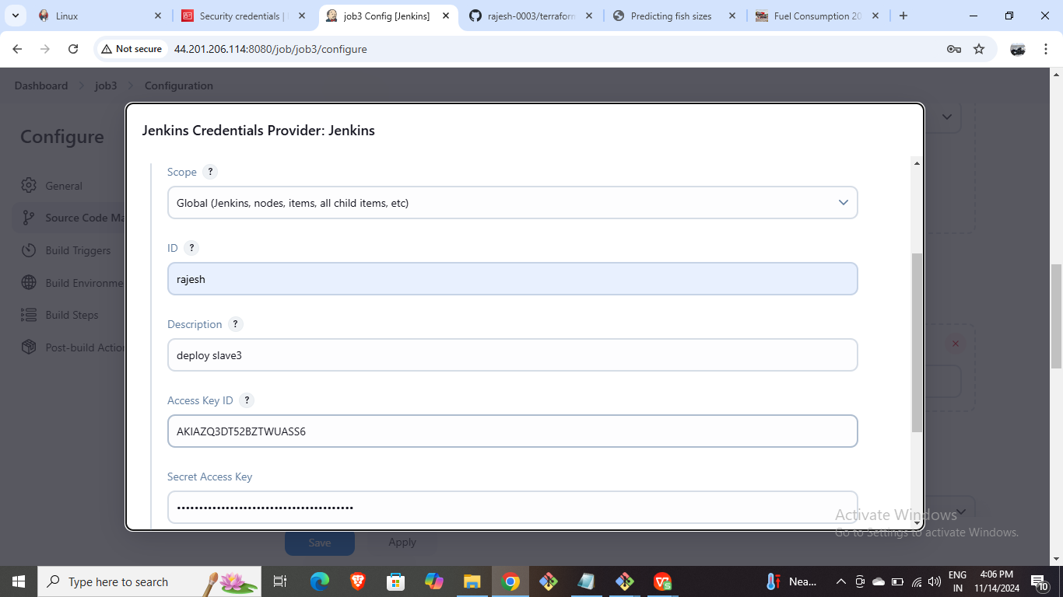

* Add the below script on execute shell.

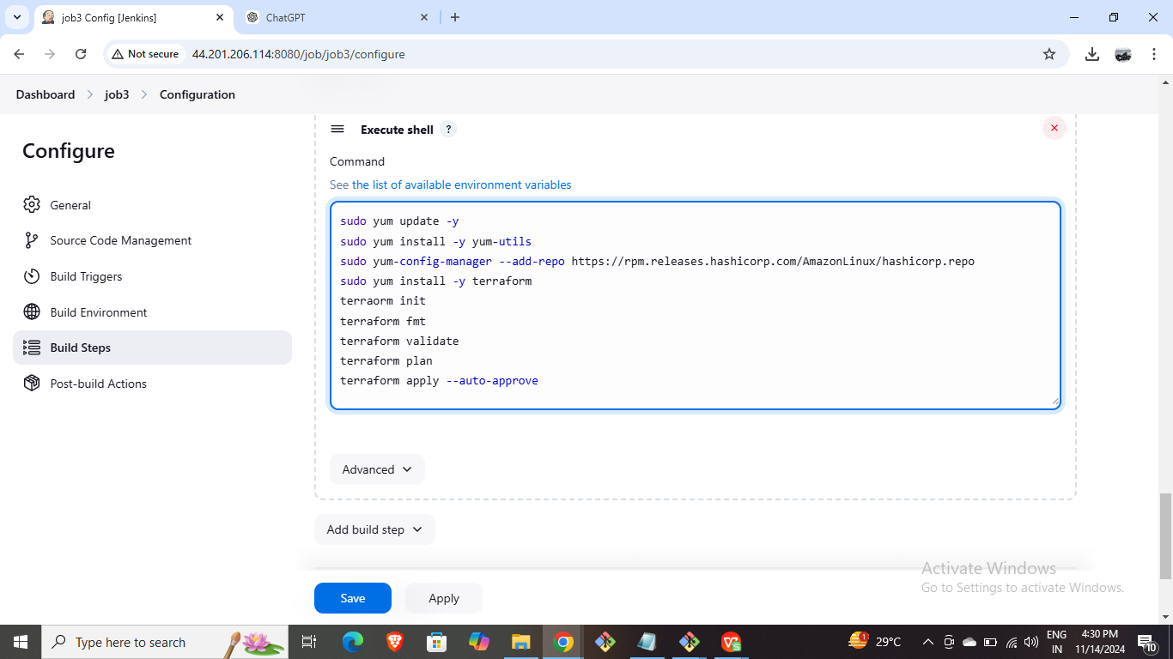

* Build the job and observe that the new EC2 Instance is created in AWS Console.



* Copy and Browse the public IP of the created instance.

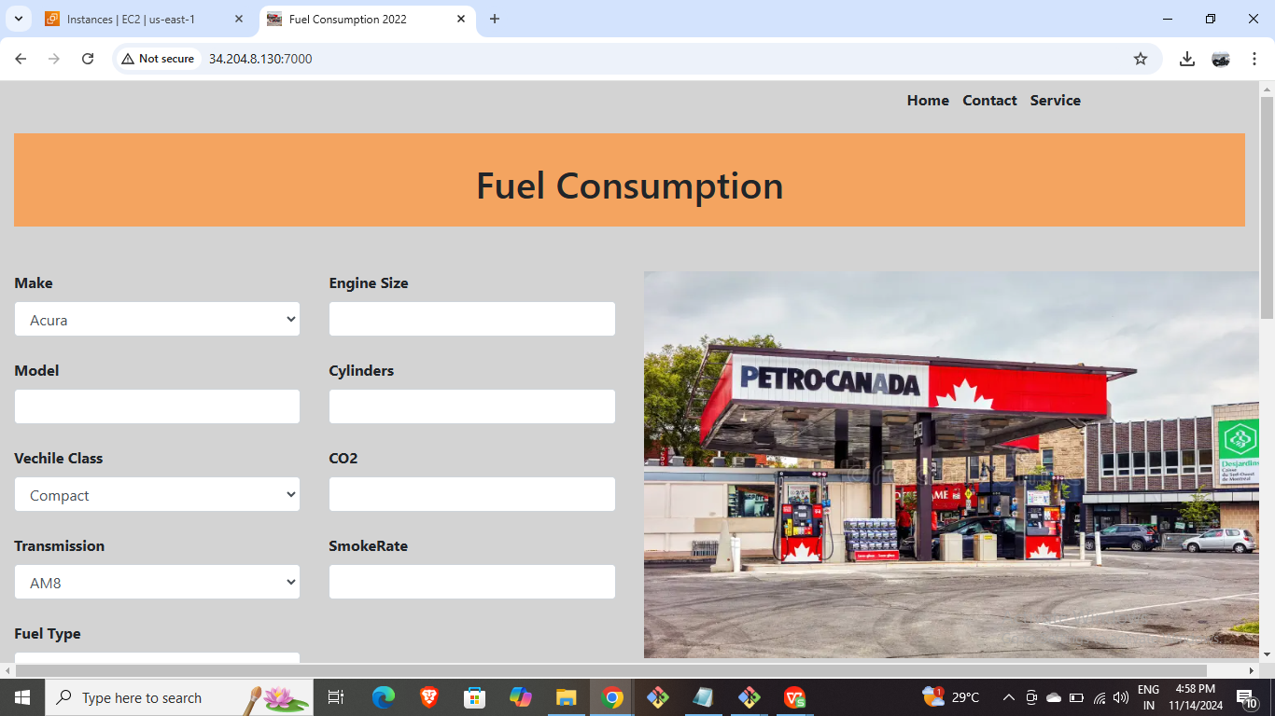

* Slave 4 : Deploy java-based application manually.
* Create new EC2 Instances for both Master and Slave-4.
* Connect the master with the CLI and generate ssh keys and install Jenkins.

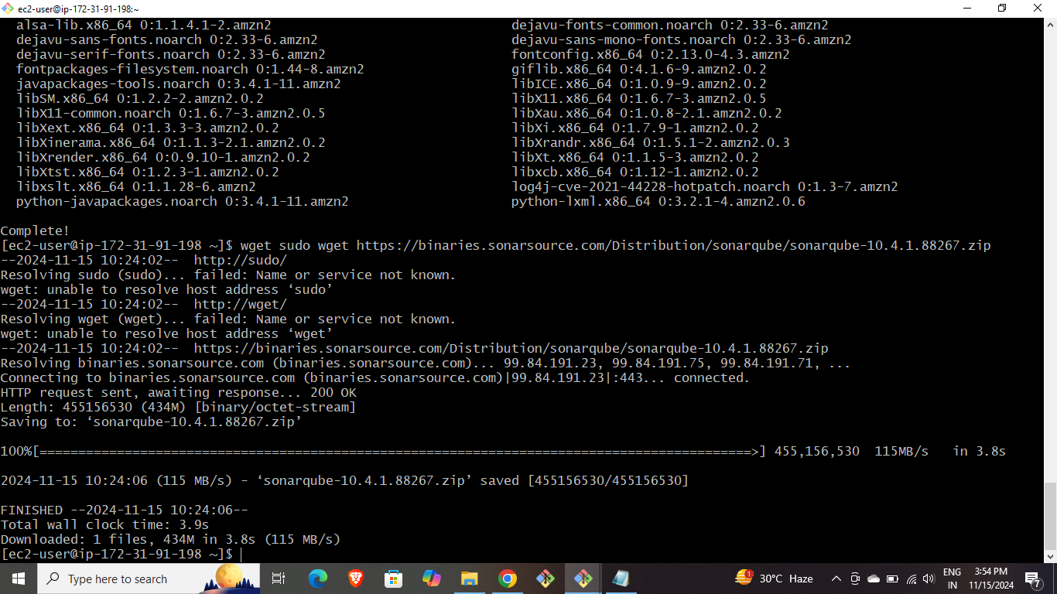

* Connect the slave server with the CLI and install java-17 in it and provide ssh key.

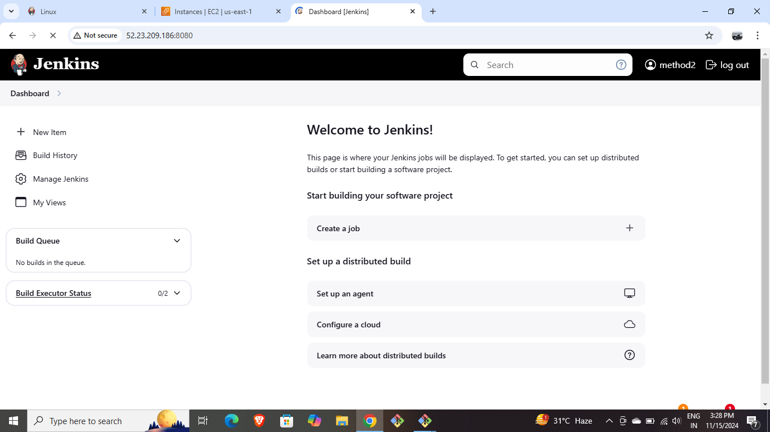

* Create a node for Slave4 using required configurations.

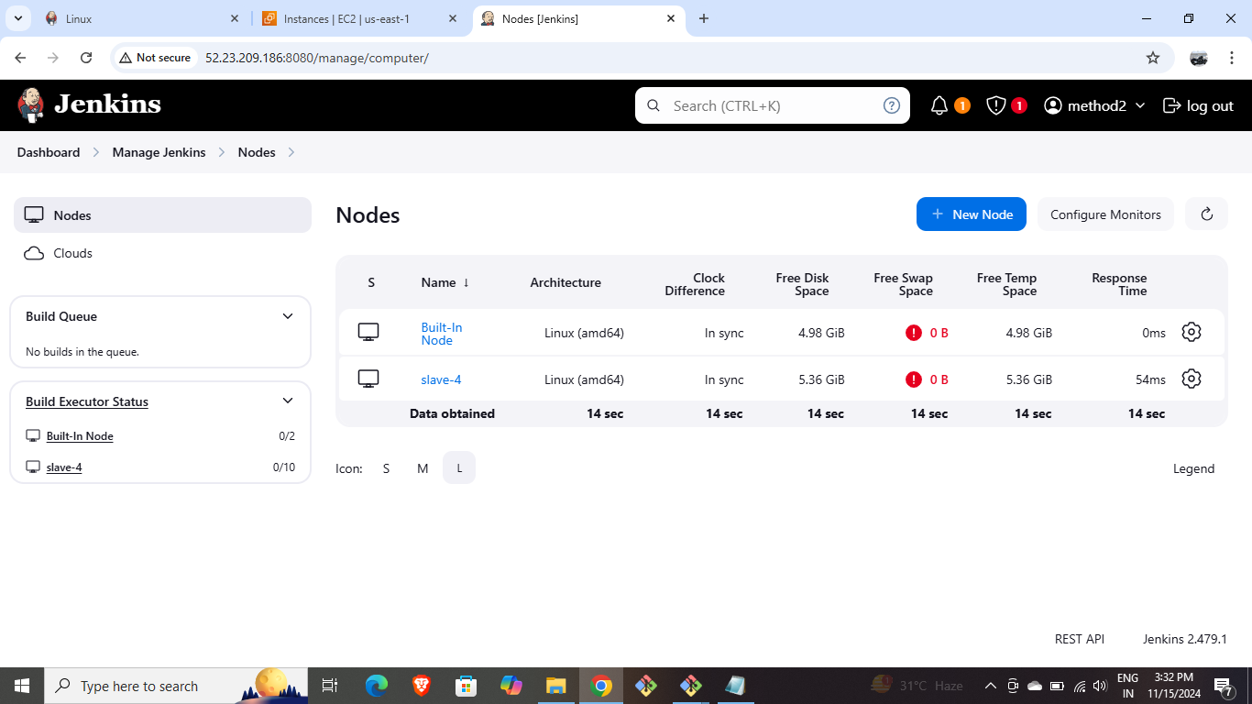

* Create a new job named Clone-Job and provide git repo and build it.

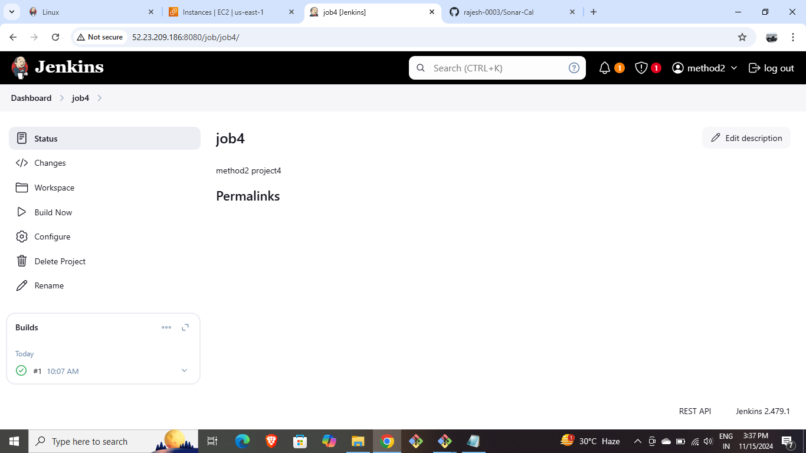

* In Manage Jenkins under Tools edit the Maven Installations long with version.

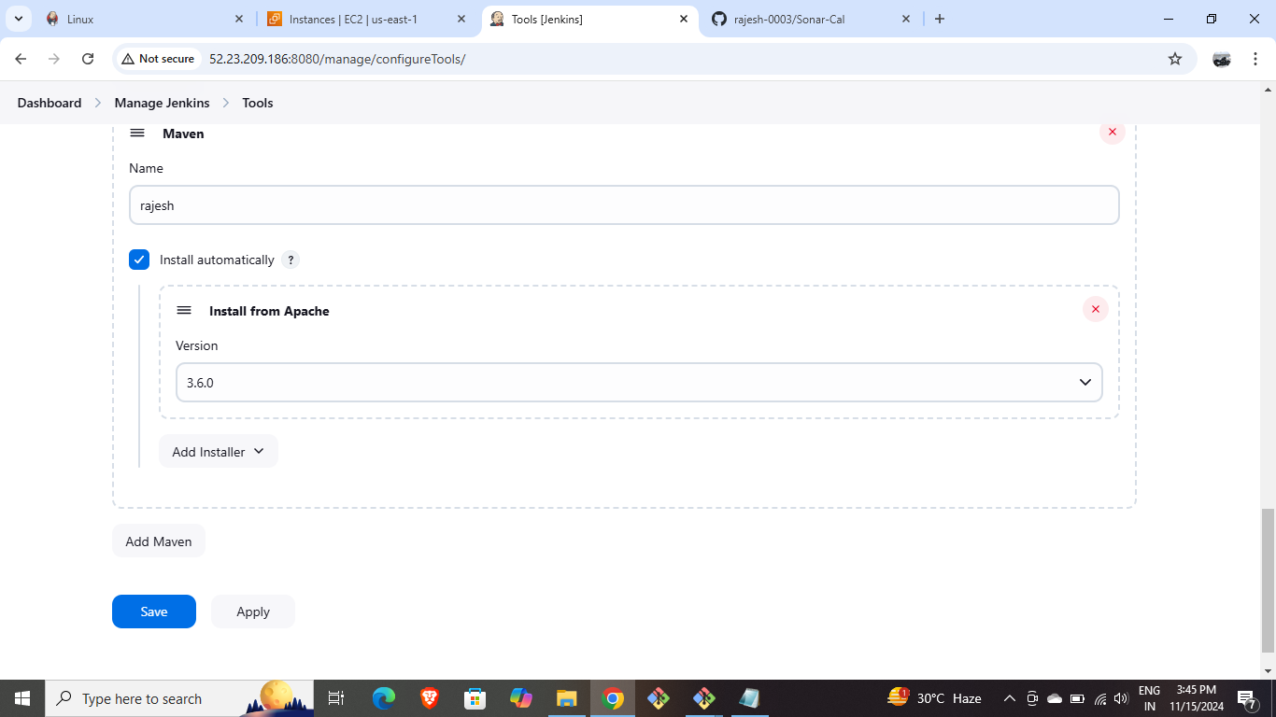

* Create a new job named Build-Job (copy from Clone-Job) and give maven details in Build steps as shown below and build it.

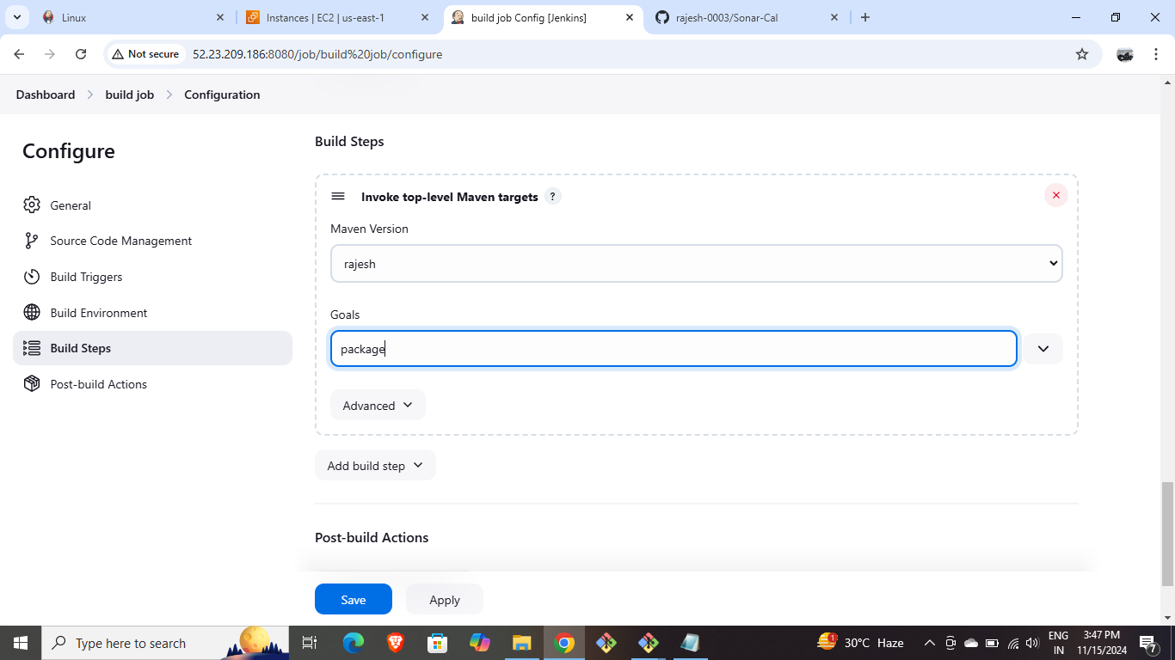

* Create another EC2 Instance for SonarQube.
* Connect it through CLI and install Sonarqube and unzip it.
* Go inside unzipped SonarQube directory and then go into bin and then into linux and then we’ll find sonar.sh file run it and start it.

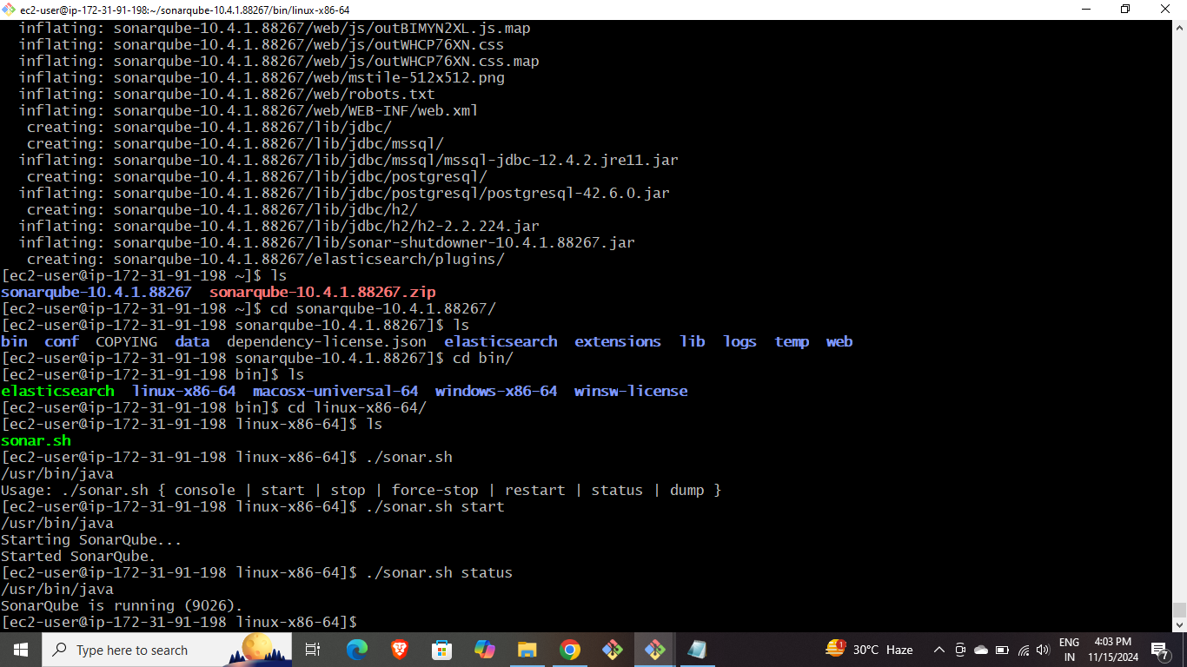

* Now browse the public IP of the SonarQube instance to get SonarQube web page.

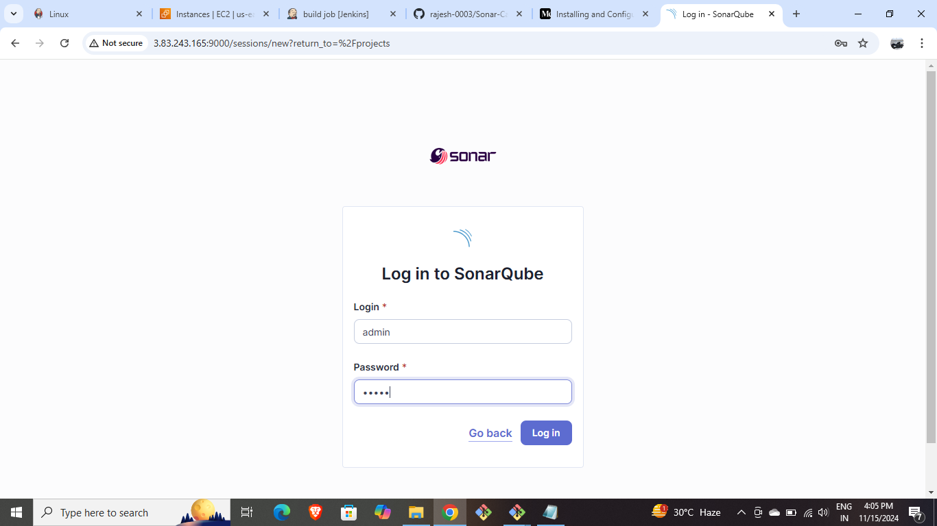

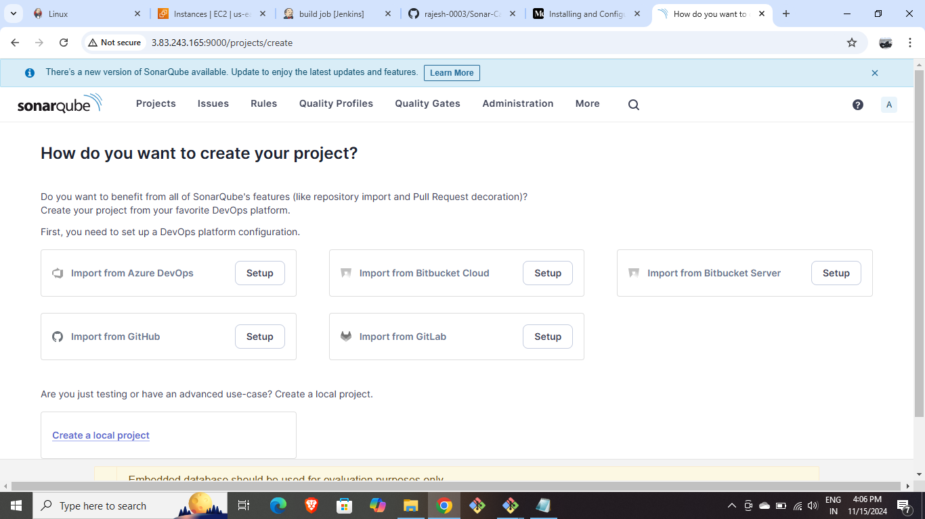

* Under security and users ,Create a token.

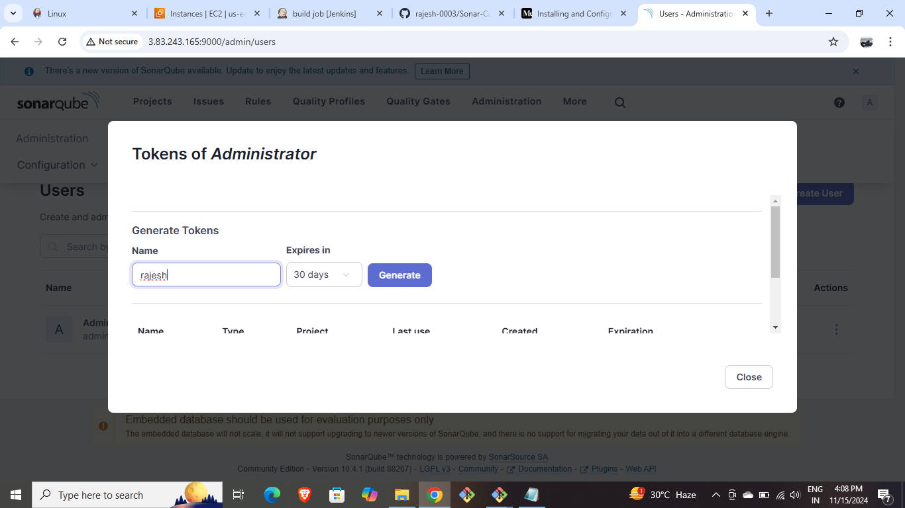

* Goto Create Global credentials in Jenkins and edit sonar settings as below by providing the token created above.

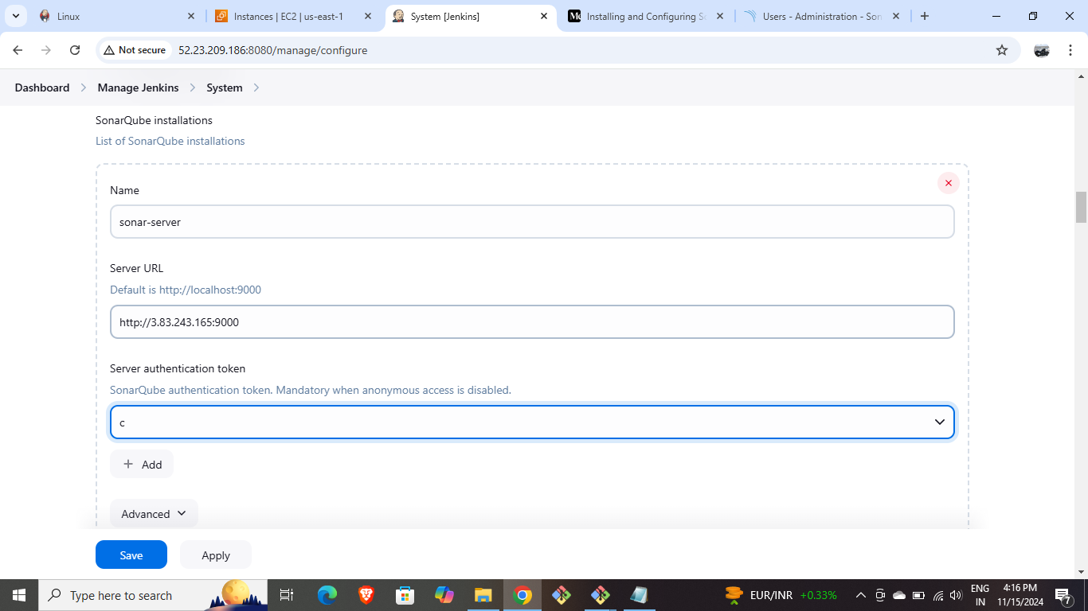

* Under System settings edit the SonarQube servers as shown below by providing SonarQube running server IP address.

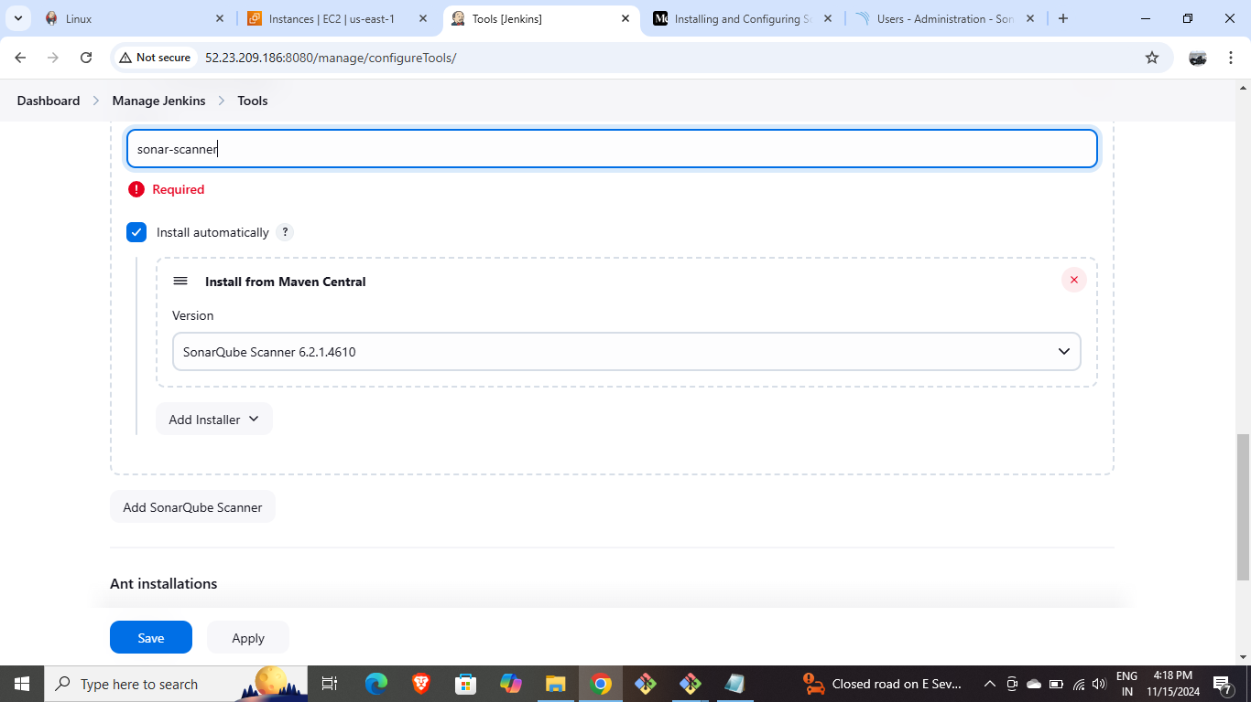

* Under Tools, provide SonarQube version as shown below.

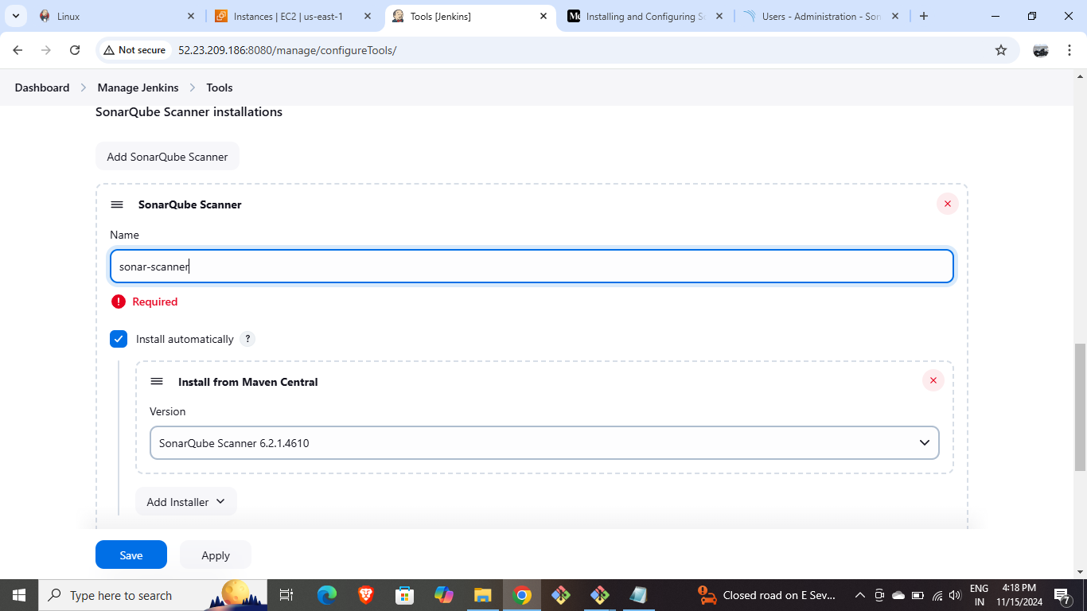

* Create a new job named Test-job and add a maven build step and change goals of it.
* In the provided GitHub repository edit the pom.xml file by providing the Public IP address of the SonarQube running page and created Token.

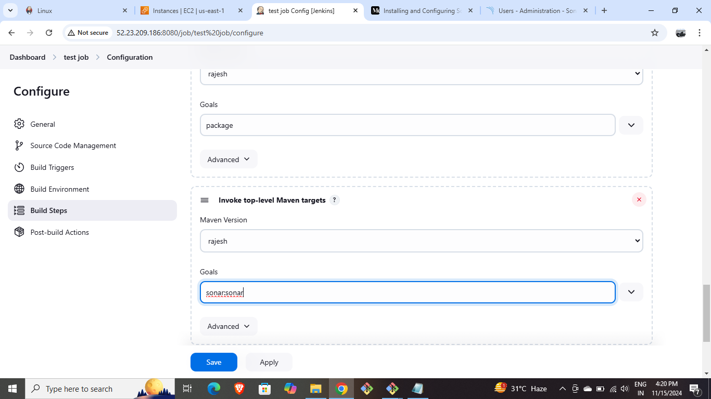

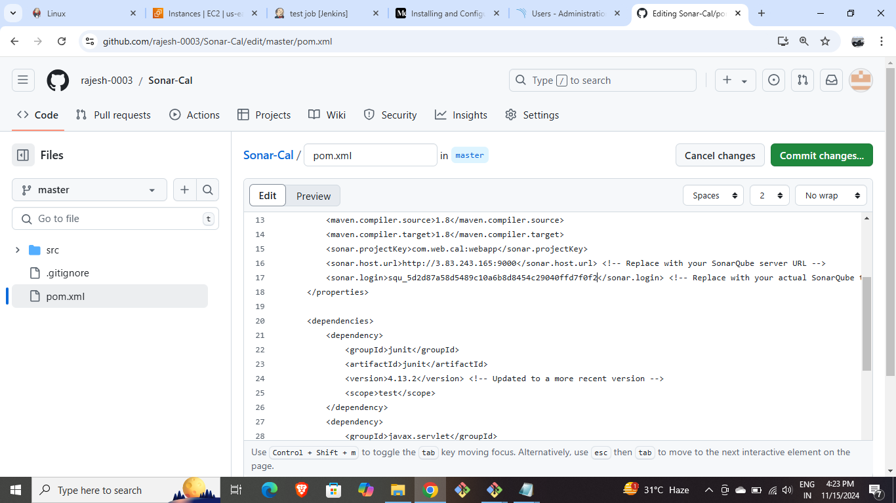

* Build the Test-job.

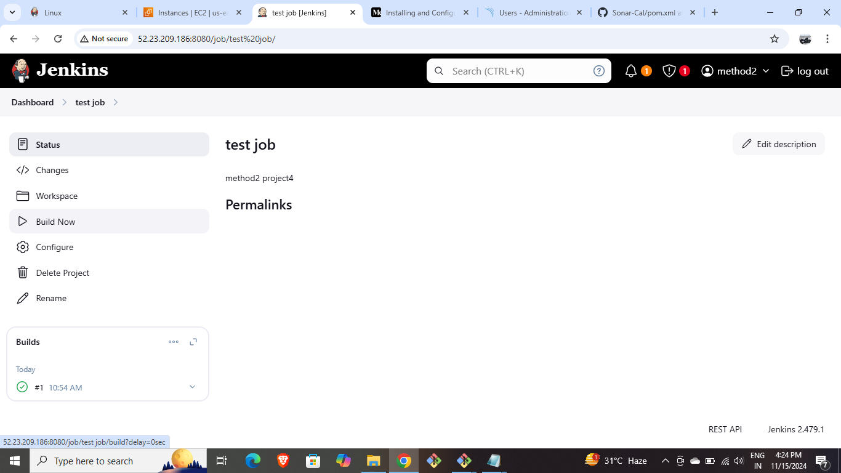

* Create a deploy-job and under post-build actions provide war file address.

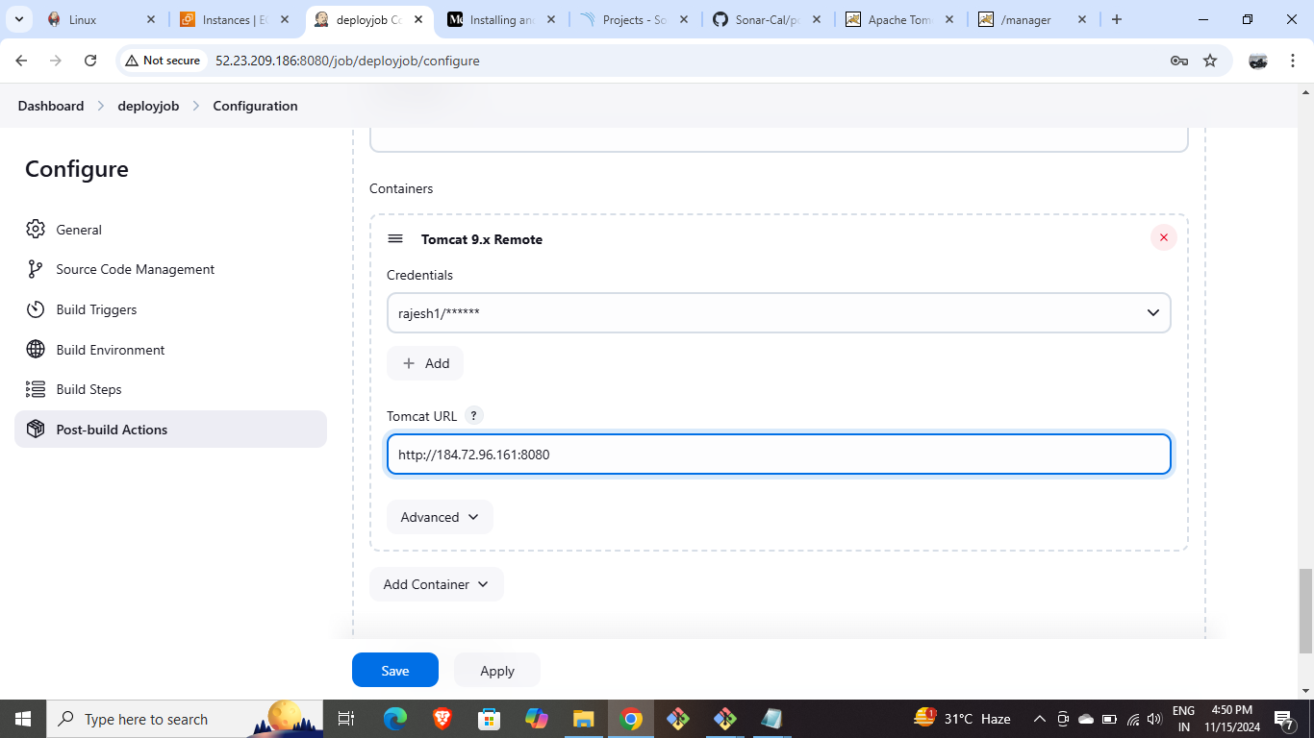

* Install the Apache Tomcat in the slave server CLI and extract it.

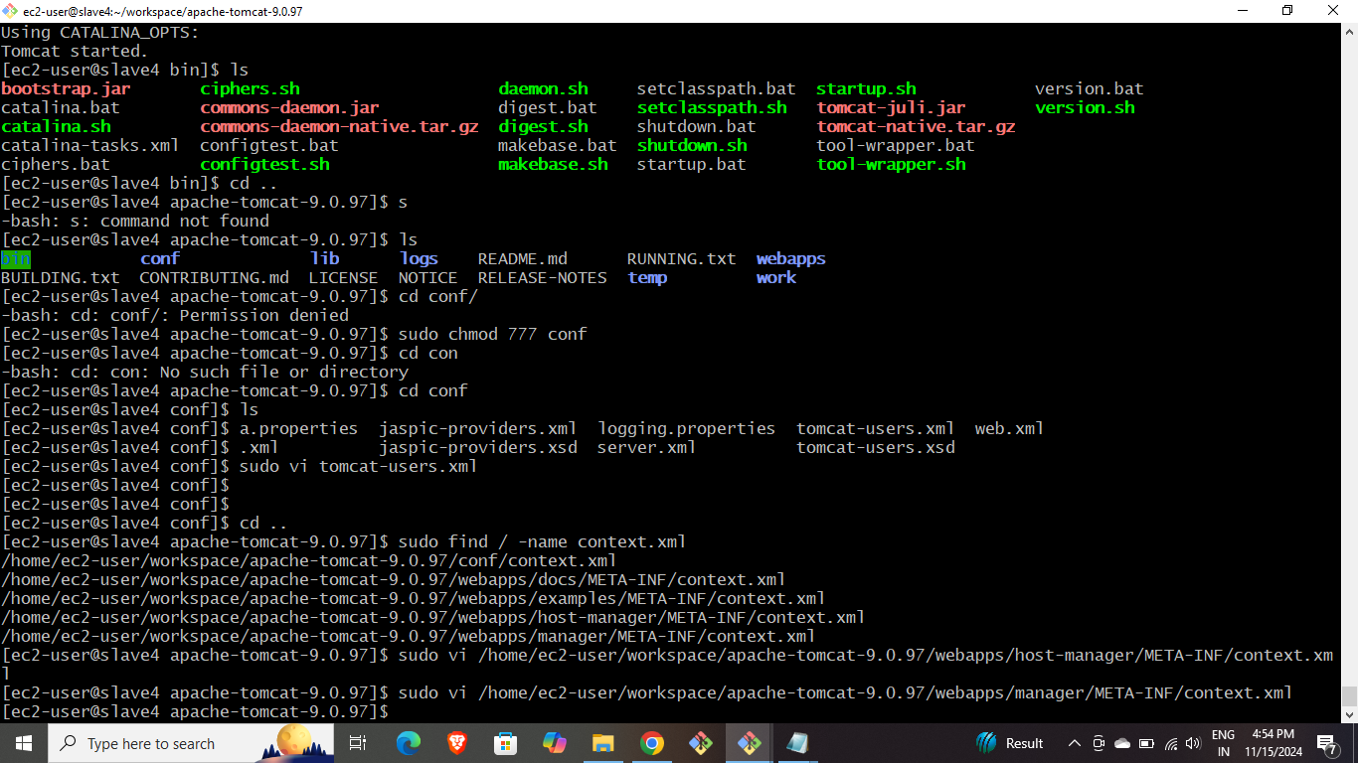

* Go inside conf directory and change the port number of tomcat by going inside the server.xml file as shown below and run it

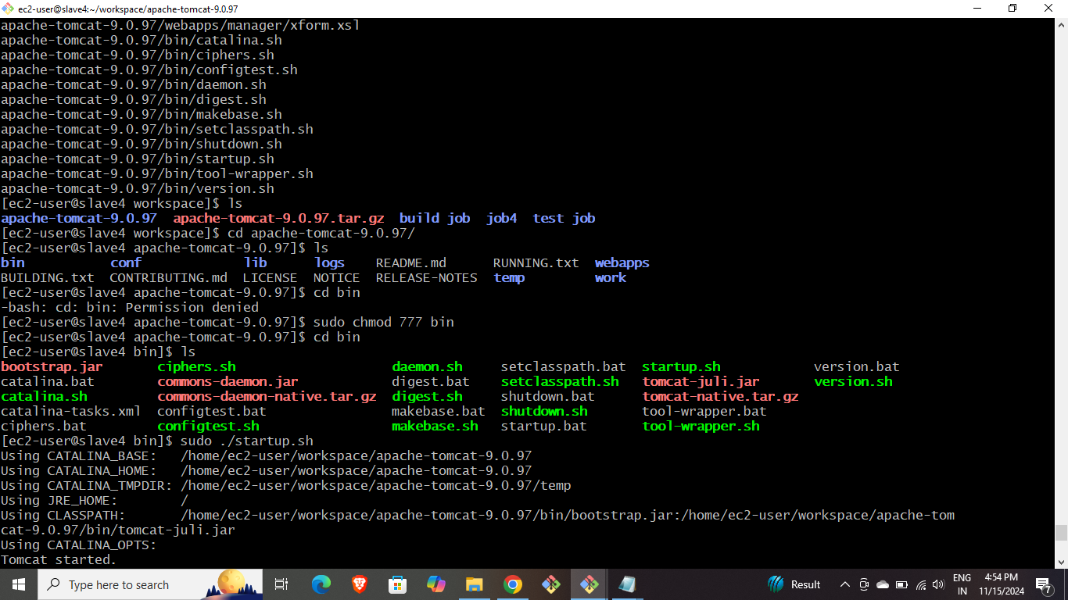

* Changing port number in server.xml file.

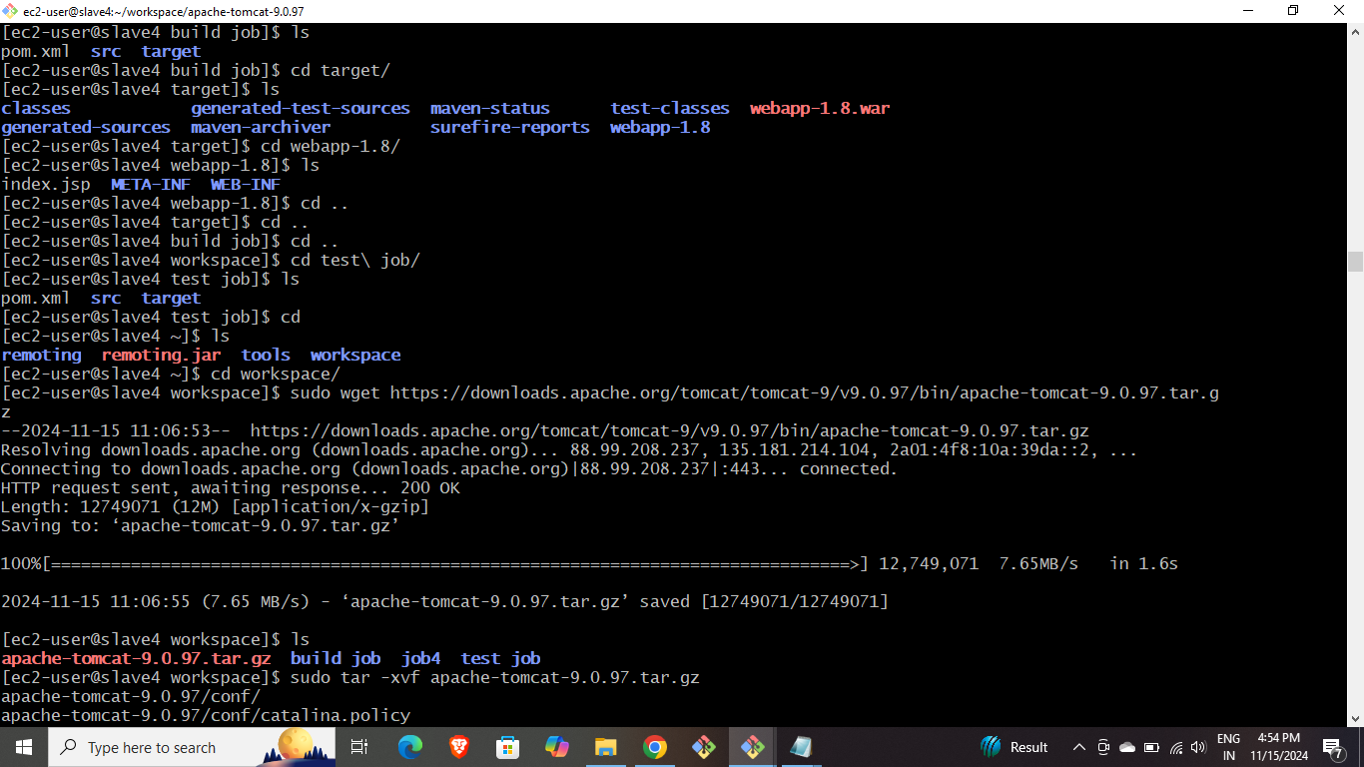

* Browse the public IP of the slave and browse it with the assigned port number to get the Apache Tomcat home page.

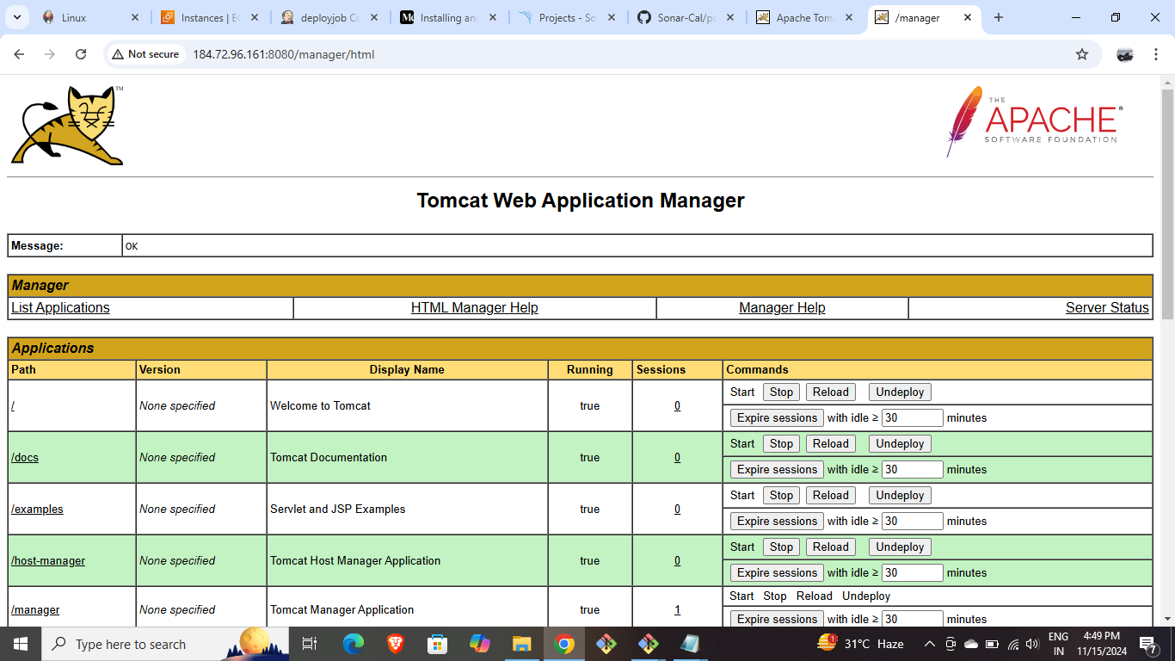

* Find out the context.xml files using command shown below.

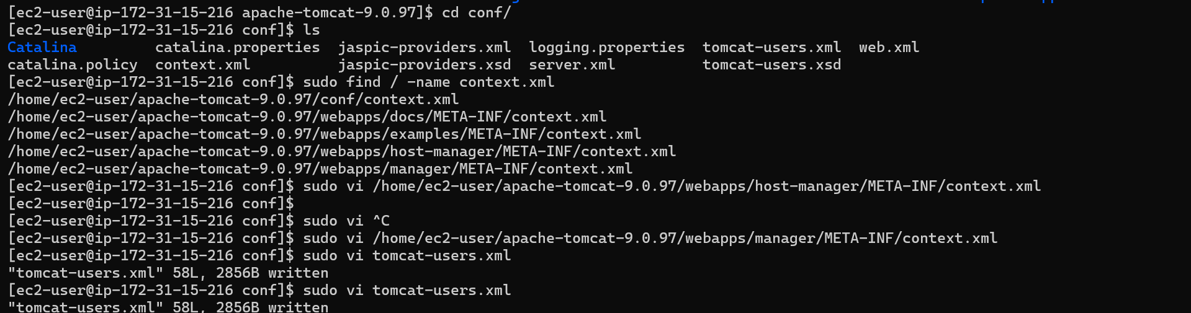

* Comment the valve lines of host-manager file.
* Comment the valve lines of manager file.
* Assign username & password for manager-gui and manager-script in tomcat-users.xml file.
* Provide the username and password created for manager-script under credentials tab for deploy job of Jenkins.
* Edit containers by giving credentials created and IP of the Tomcat server.



* Build all the jobs.

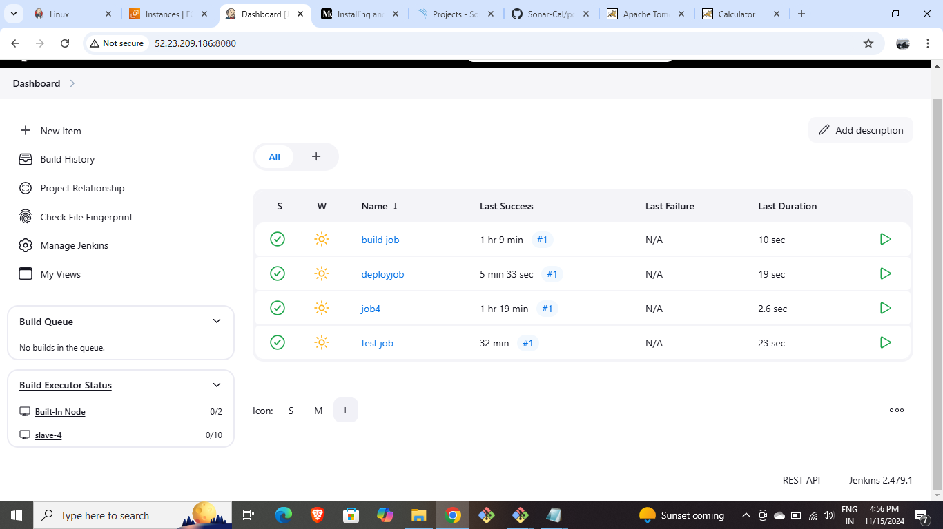

* Refresh the Tomcat server and provide credentials and then we’ll get application manager.



* Click on webapp.1.8 and then we’ll found that our java calculator app id hosted.

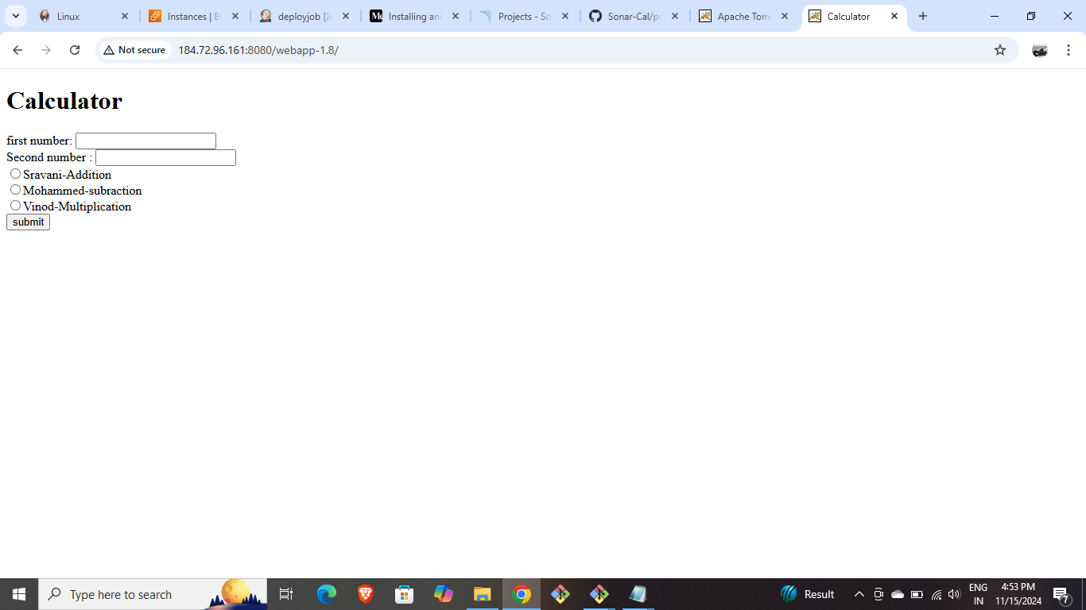

* Provide inputs and observe outputs.

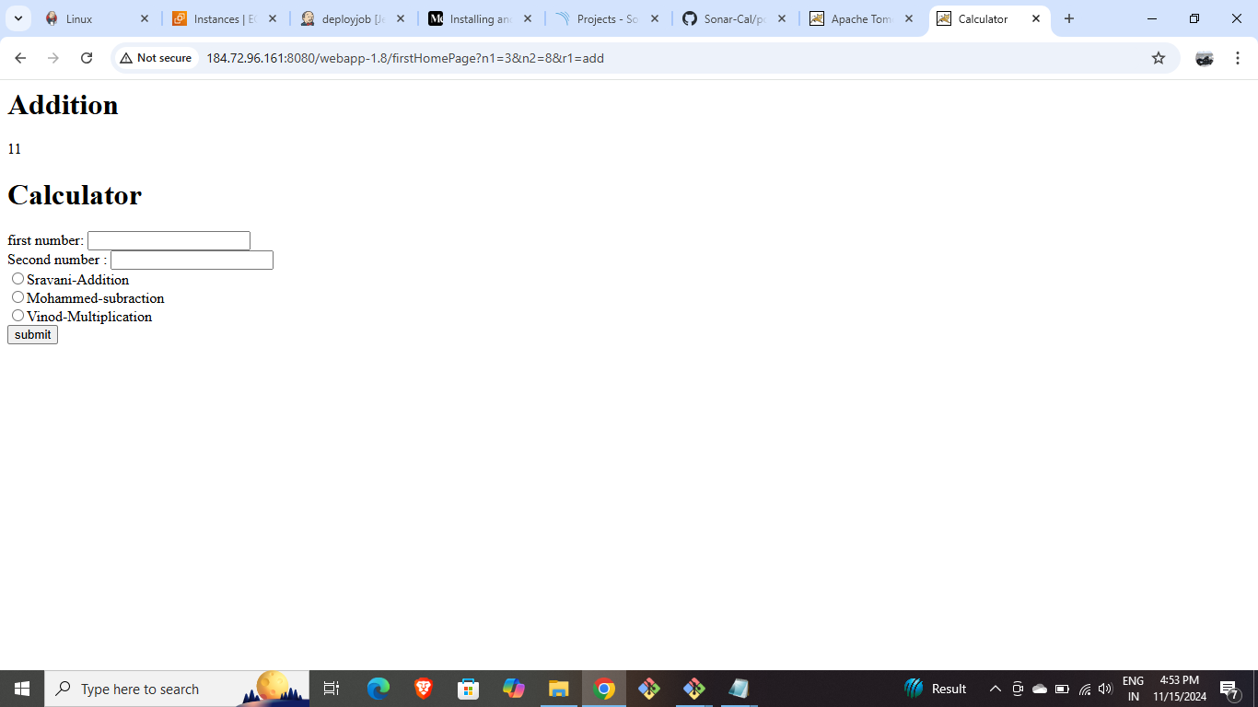

* Slave 5: Deploying java web application using bash script.
* Create EC2 Instances for both Master and Slave5.
* Connect the Master through the CLI and install Jenkins and also generate ssh keys in it.

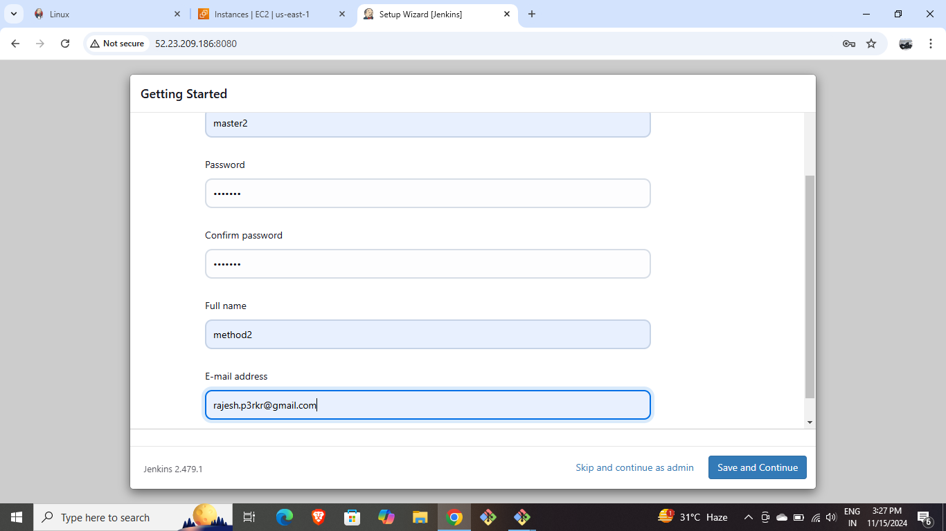

* Connect the slave-5 server and install java-17 and provide ssh key in it.
* Create a Jenkins node for Slave-5 with required configurations.

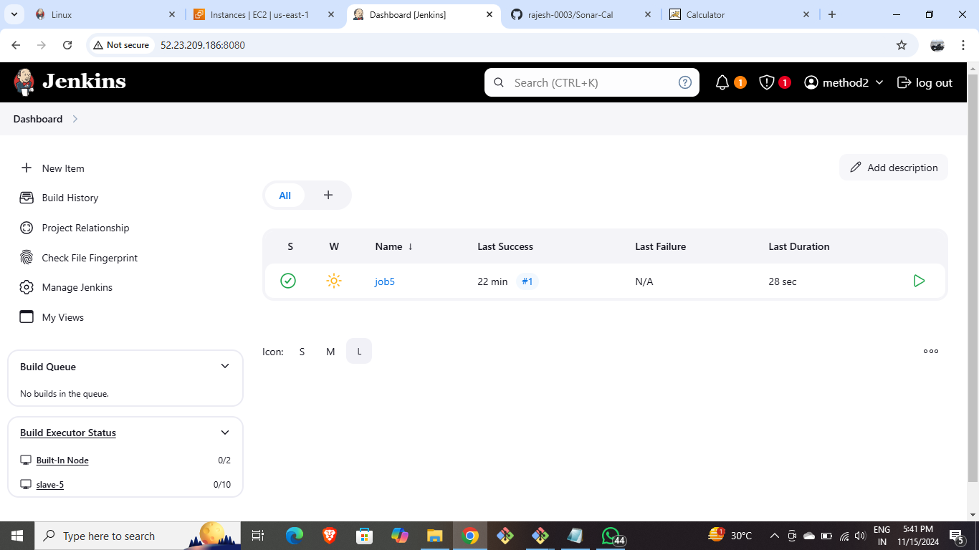

* Create a new job with restrict labels and git repository required.

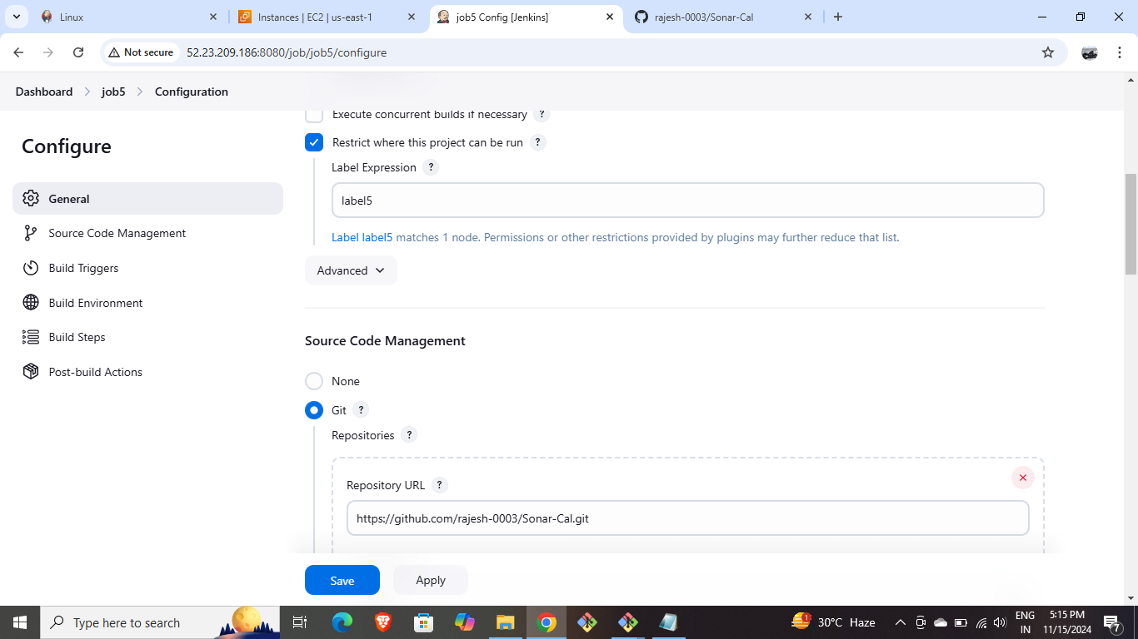

* Add the below script in Jenkins execute shell.

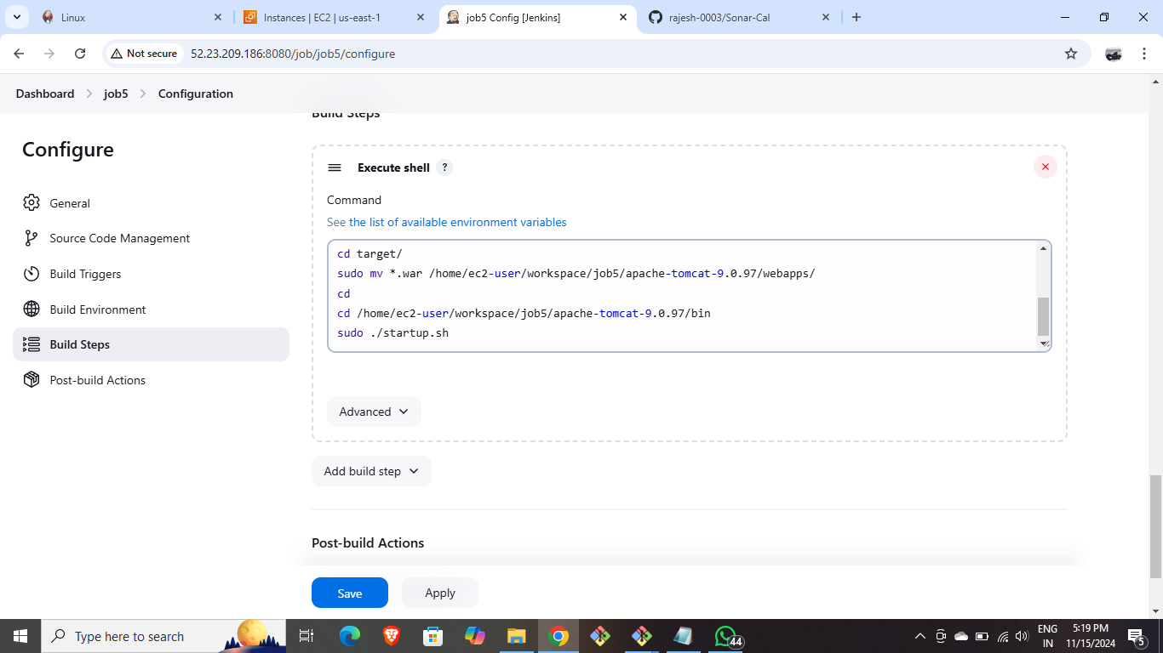

* Build the job.



* Go inside the workspace manually and edit the host manager and manager files.

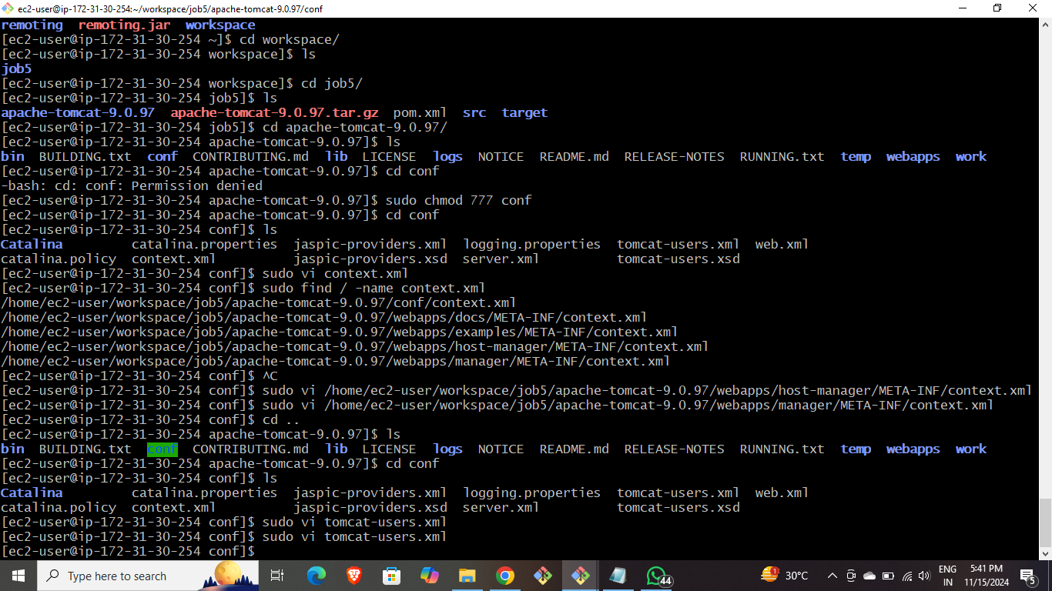

* Edit the tomcat-users.xml file to give username and password.

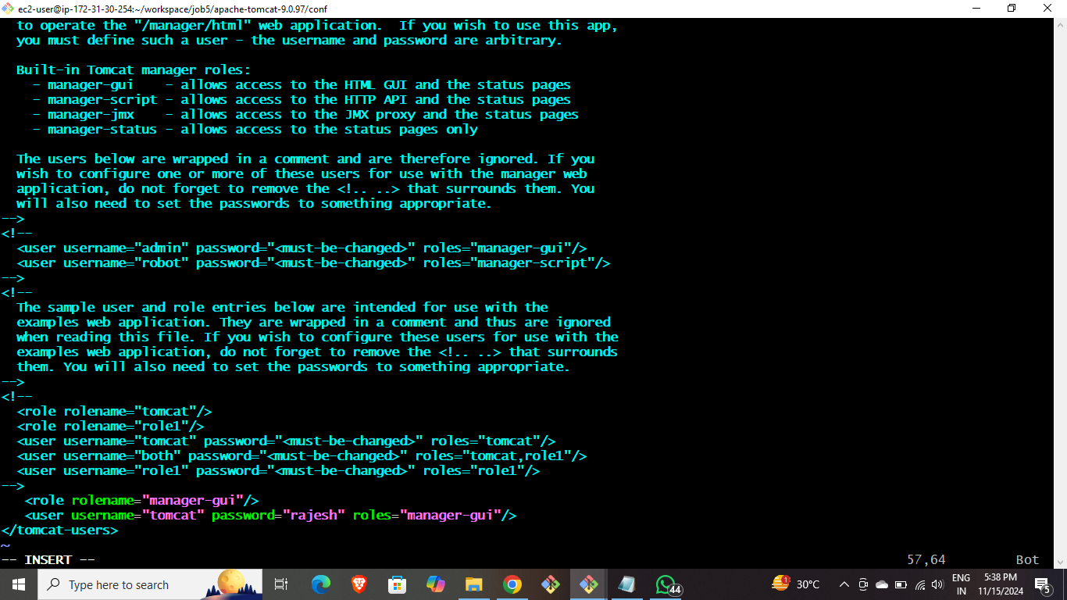

* Edit the Username and password as below.
* Copy and browse the public IP of the instance for Tomcat web page and click on manager app for username and password page and enter the username and password manually to get webapps.1.8 file in it.

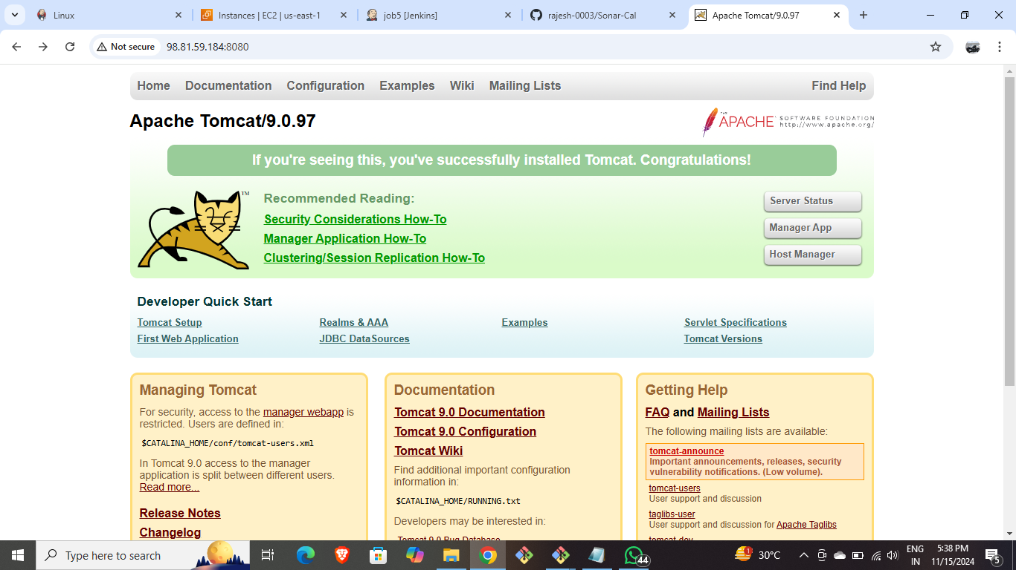

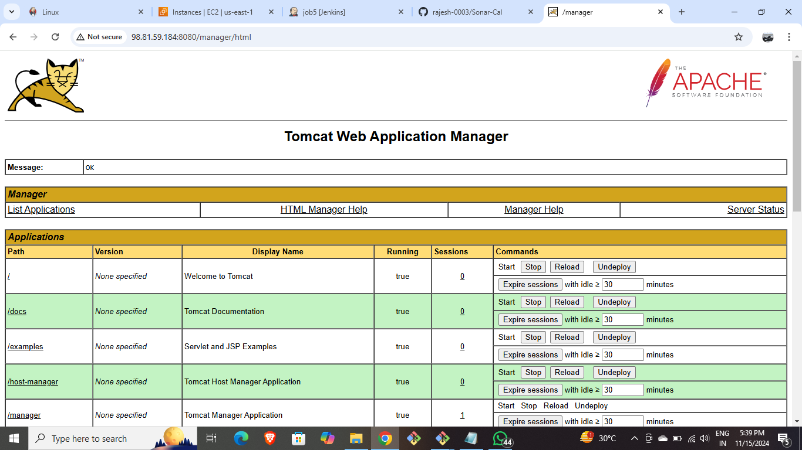

* Click on wenapps.1.8 to get the hosted application.
* Provide the inputs and observe the outputs.

